An Analysis of Dengue Outbreaks in the Colombo Disctrict, Sri Lanka

A Data Analysis Project

Ian Bachli

2019-11-27

# Summary/Abstract

*Write a summary of your project.*

# Illustrating setup

*This section is only there to show how to insert results from other places in the project and how to cite figures and other references. Delete this whole section at some point.*

This paper (Leek & Peng, 2015) discusses types of analyses.

Figure 1 shows a result figure from the analysis.

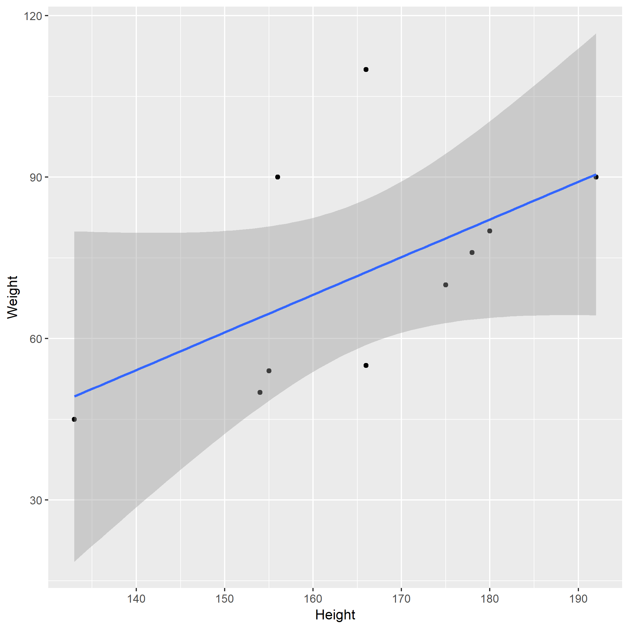

Figure 1: Analysis figure.

Table 1 shows a result table from the analysis.

Table 1: Result Table.

|  |  |  |  |  |
| --- | --- | --- | --- | --- |
| term | estimate | std.error | statistic | p.value |
| (Intercept) | -43.7883068 | 61.1150617 | -0.7164896 | 0.4940713 |
| Height | 0.6996272 | 0.3675692 | 1.9033889 | 0.0934786 |

Note that this cited reference will show up at the end of the document, the reference formatting is determined by the CSL file specified in the YAML header. Many more style files for almost any journal [are available](https://www.zotero.org/styles). You also specify the location of your bibtex reference file in the YAML. You can call your reference file anything you like, I just used the generic word references.bib but giving it a more descriptive name is probably better.

# Introduction

## General Background Information

*Dengue is a disease caused by a family of viruses transmitted to people through the bite of an infected Aedes species (Ae. aegypti or Ae. albopictus) mosquito. Symptoms of Dengue fever include severe joint and muscle pain, swollen lymph nodes, headache, fever, exhaustion, and rash. The presence of fever, rash, and headache (the “Dengue Triad”) is characteristic of dengue fever. Each year, up to 400 million people get infected with Dengue. Approximately 100 million people get sick from infection, and 22,000 die from severe Dengue. Dengue is caused by one of any of four related viruses: Dengue virus 1, 2, 3, and 4. For this reason, a person can be infected with a Dengue virus as many as four times within their lifetime. Dengue virus is prevalent throughout the tropics and subtropics; being common in over 100 countries in the world. Forty percent of the world’s population, about 3 billion people, live in areas with a risk of Dengue. Because of this, Dengue is often a leading cause of illness in areas with risk. It is clear that Dengue places a significant socioeconomic and disease burden on many tropical and subtropical regions of the world. It is currently regarded as the most important arboviral disease internationally as over 50% of the world’s population live in areas where they are at risk of the disease, and approximately 50% live in dengue endemic countries.* *Dengue outbreaks occur in many countries around the world, varied among the Americas, Africa, the Middle East, Asia, and the Pacific Islands. Many of these countries at risk are below an elevation of 6,500 feet. Sri Lanka is among the countries in which the Center for Disease Control labels Frequent/Continuous for the number of outbreaks of Dengue year to year. In 2010, the WHO reported 26,824 Cases of Dengue in Sri Lanka, leading to a reported 192 Deaths. In a more recent account in Sri Lanka, there were 180,000 reported cases in 2017; the majority of cases being reported from the Western province. The highest numbers of Dengue cases were reported during the 20th week of 2017. Sri Lankan health authorities warned that the country was facing a Dengue epidemic with at least 301 patients dead. It is clearly evident from data collated by WHO that, in SEA, an overall expansion of dengue has occurred over the last decade. In 2003, eight countries in SEA had reported cases of dengue and, by 2009, all SEA member countries excluding the Democratic People’s Republic of Korea reported indigenous cases. Epidemics continue to persist on regular 3–5 year cycles throughout SEA, and the number of reported cases continues to increase along with the severity of cases in many member countries.*

## Description of Data & Data Source

*The following data is a collective of samples of weekly notified Dengue cases and climate variables in the Colombo district of Sri Lanka between the years of 2008 to 2014. Within the data frame there are 279 rows and 12 variables. During the sample time, the 12 tested variables were: Total number of notified Dengue cases (Cases), Year (Year), Week number to locate the week within a year (Week), Week_Continuous across 6 years, Average temperature of the week (TEM), maximum temperature of the week (TMAX), Minimum temperature of the week (Tm), Sea level pressure (SLP), Relative humidity (H), Precipitation amount (PP), Mean visibility (VV), Mean wind speed (V), and Maximum sustained wind speed (VM). An additional variable was added by myself, named “Week Continuous”, to show a full timescale of changes across the years, week by week.*

*The data was provided by Thiyanga Talagala, and published in 2018, taken from the weekly epidemiological reports published by the Epidemiological Unit, Ministry of Health, Sri Lanka. You can find the link to the data* [*here*](https://CRAN.R-project.org/package=colmozzie)*.*

## Questions/Hypotheses to be Addressed

*Examine Seasonal Changes across the Timespan of the Data Collection to observe any noticeable changes that may play a role in the number of Cases of Dengue recorded.* *Which variable/variables are the best indicators for Dengue?* *Can the indicators for Dengue be applied to similar ecosystems across the world devoid of Dengue if the vector was introduced to that area to provide an example as to how many cases of Dengue in those areas we would see?* *Does Maximum Sustained Wind Speed play a role in lower Dengue cases?* *How does Sea Level Pressure affect Dengue and its Vector?* *Does the Vector prefer warmer or cooler temperatures in tropical/subtropical zones when spreading Dengue?* *Does Precipitation attribute to higher Dengue cases?* *What additional variables would be beneficial to include in the dataset for future studies? For example, exact longitude, latitude, etc.*

# Methods and Results

*The data was provided by Thiyanga Talagala taken from the weekly epidemiological reports published by the Epidemiological Unit, Ministry of Health, Sri Lanka. Data was further cleaned by myself to better fit my analysis. Data was analyzed using R Studio software and various R packages listed throughout the repository provided by Github. Methods will include examining the variables in detail to see which ones are the best predictors and indicators for Dengue. Comparing each other variable to the number of cases of Dengue provides us with some ideas on what variables seem to have the most weight when it comes to identifying Dengue predictors, or at least which variables correlate with the number of Cases of Dengue.*

## Data Aquisition, Import, and Cleaning

*The data was provided by Thiyanga Talagala, and published in 2018, taken from the weekly epidemiological reports published by the Epidemiological Unit, Ministry of Health, Sri Lanka. You can find the link to the data* [*here*](https://CRAN.R-project.org/package=colmozzie)*. Due to the fact our data was very clean from the start, we did not require a lot of script to purify our data. I did add an additional variable that counts the weeks in a continous fashion in order to examine the data over the course of the years of collection. You can examine the cleaning script in the code folder inside the DengueProcessing_cleaning.Rmd.*

## Univariate analysis

*Use a combination of text/tables/figures to explore and describe your data. You should produce plots or tables or other summary quantities for most of your variables. You definitely need to do it for the important variables, i.e. if you have main exposure or outcome variables, those need to be explored. Depending on the total number of variables in your dataset, explore all or some of the others.*

*An Exploratory analysis of the cleaned Dengue dataset shows some general trends across the variables measured against the number of Cases of Dengue reported each week, and identifies specific aspects of the code that possibly warrant a deeper analysis. The first variables we examined will be listed below. Each variable was compared to the Reported Number of Dengue Cases Weekly, as we are searching for trends among what variables may attribute to a higher percentage of Cases of Dengue.*

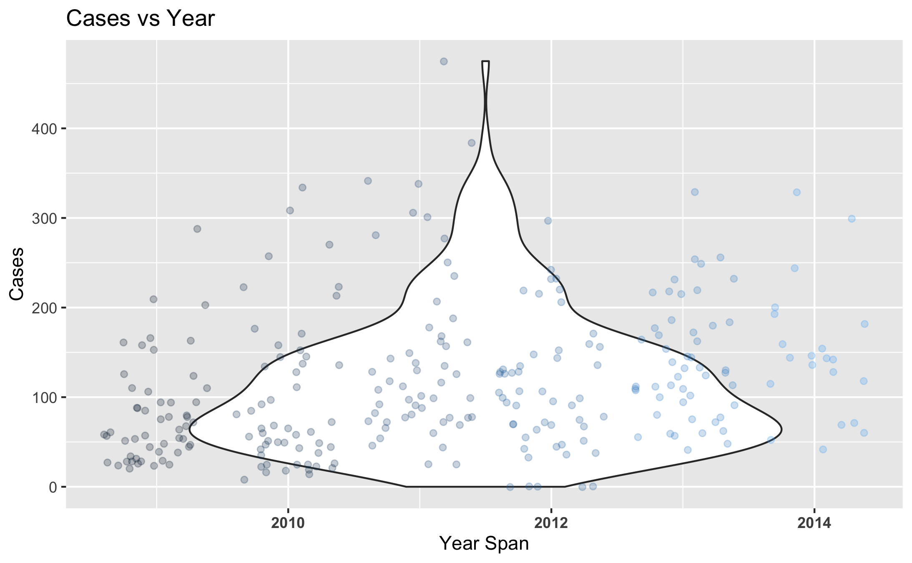

Figure 2: Number of Dengue Cases Reported Weekly Each Year.

*Here we examine the distribution of recorded cases of Dengue in the Colombo District of Sri Lanka from years 2008 - 2014.*

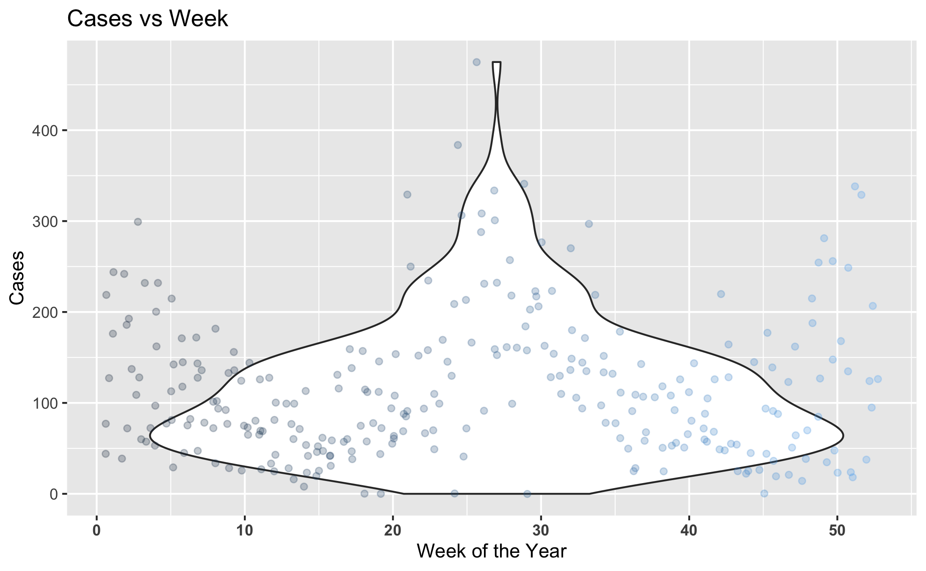

Figure 3: Number of Dengue Cases Reported Each Week.

*Here is a distribution of the average recorded cases per week across the years of the study.*

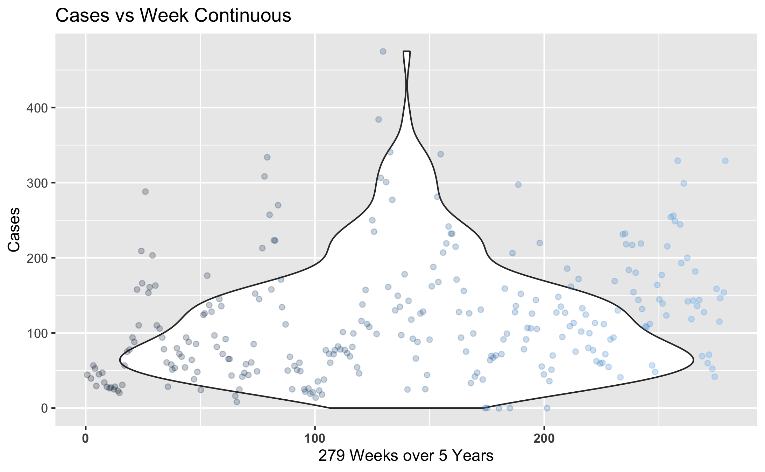

Figure 4: Number of Dengue Cases Reported Each Week Continuously.

*Here is a distribution of the number of recorded Dengue Cases across the 279 Weeks within the 2008-2014 year span.*

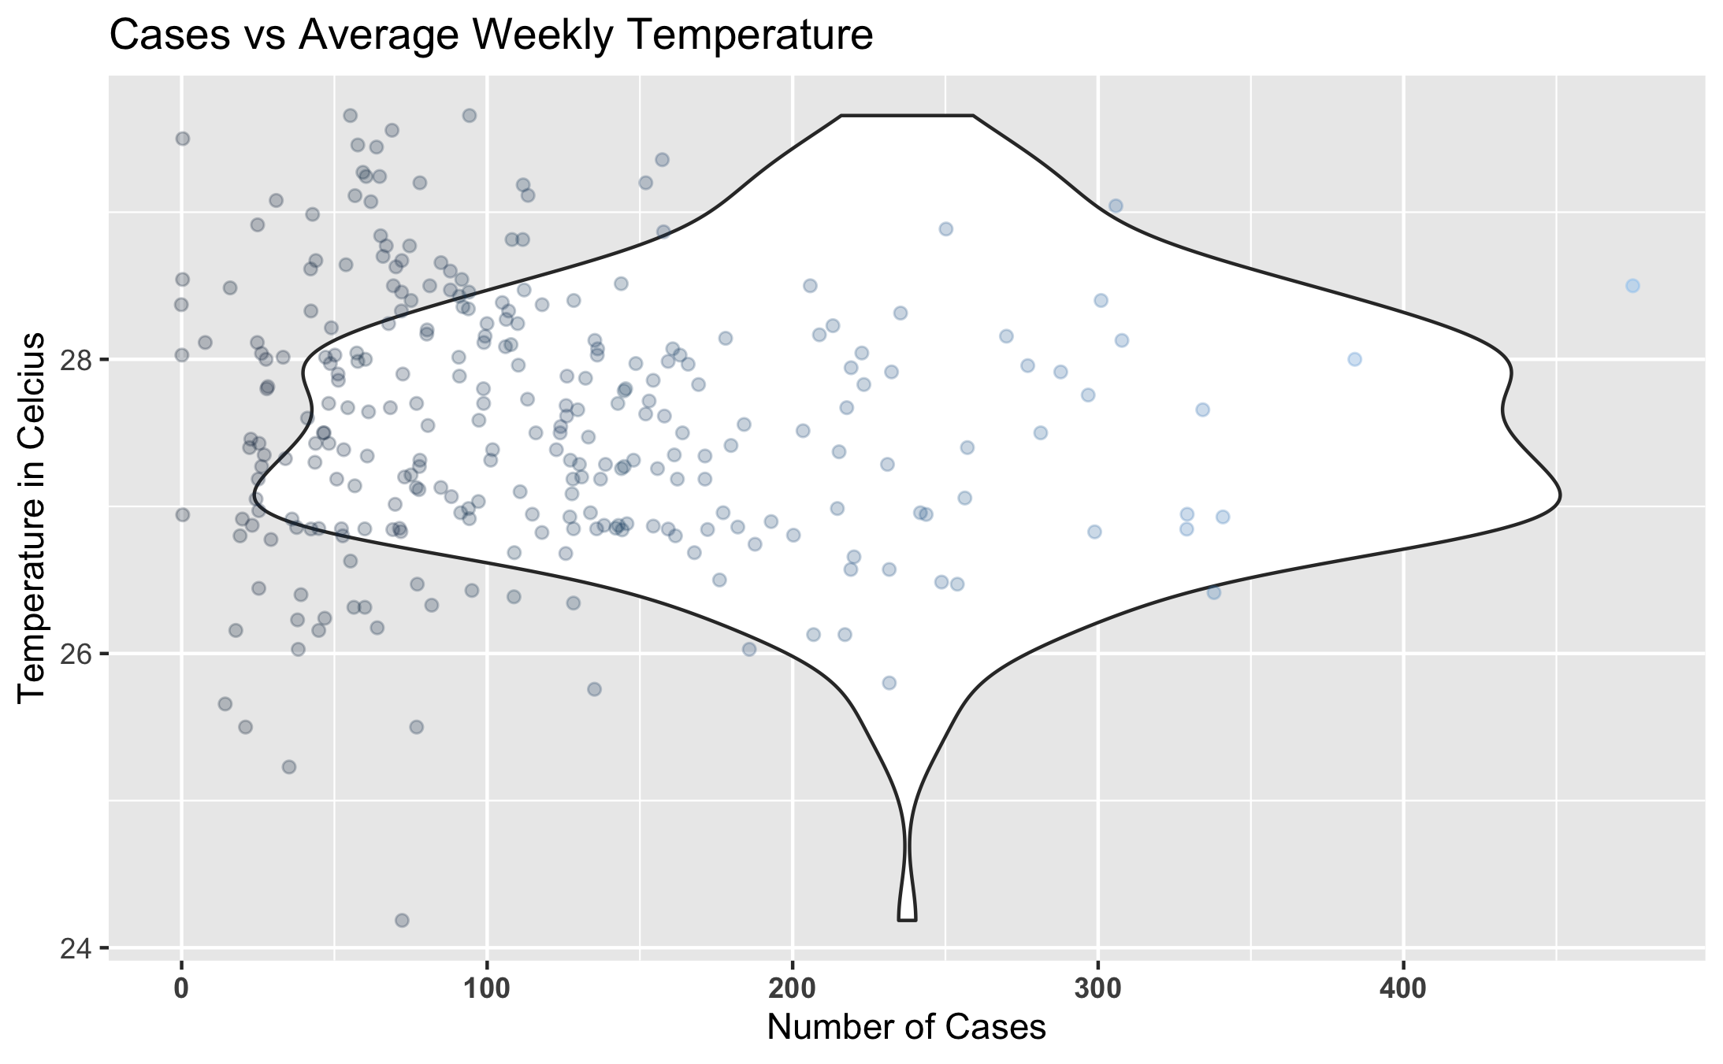

Figure 5: Number of Dengue Cases Weekly against the Average Temperature.

*Here we examine how the Temperature compares to the Number of Recorded Cases of Dengue.*

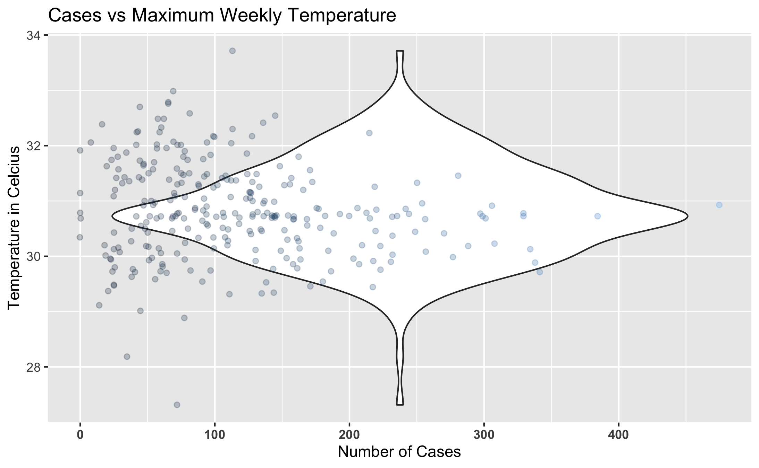

Figure 6: Number of Dengue Cases Weekly against the Temperature Maximum.

*Here we examine the comparison of the number of Record Dengue Cases Weekly against the Weekly Temperature Maximum.*

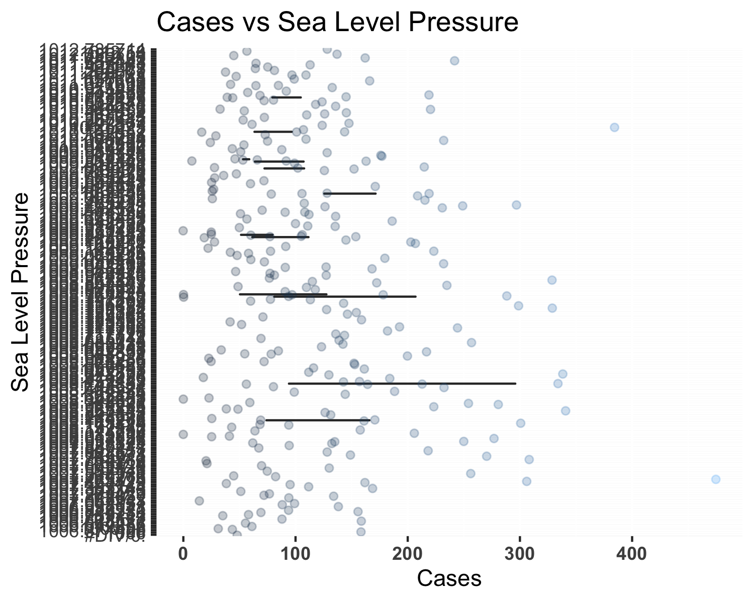

Figure 7: Number of Dengue Cases Weekly against the Sea Level Pressure.

*Above is the comparison of Sea Level Pressure differences against the number of recorded Cases of Dengue each week.*

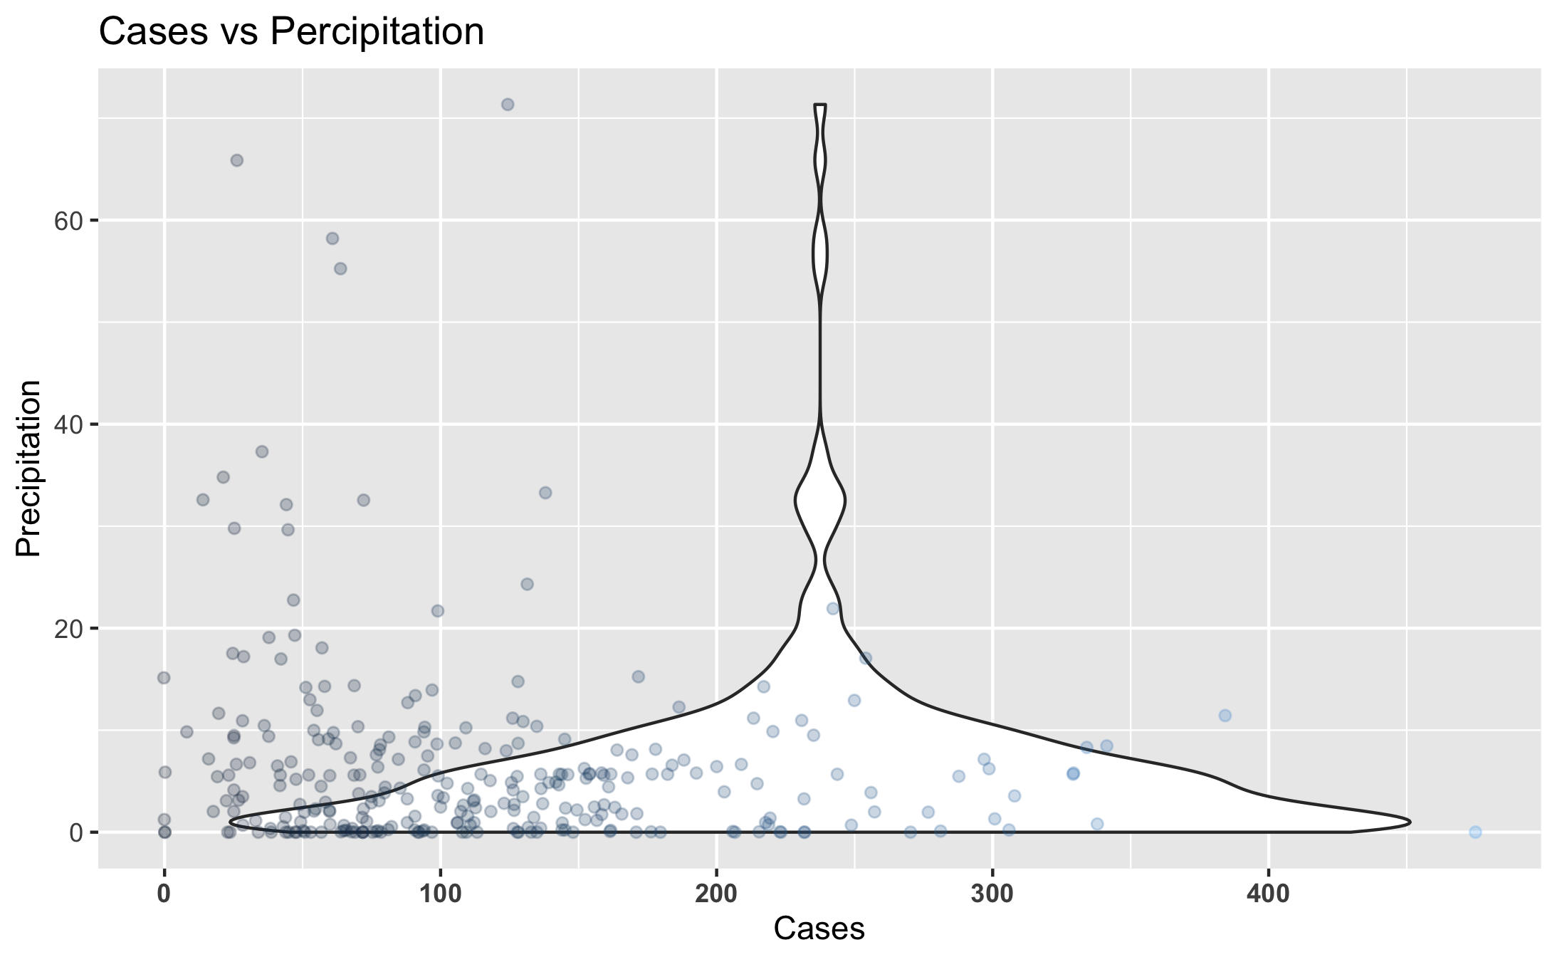

Figure 8: Number of Dengue Cases Weekly against Precipitation.

_Here is look at the comparison of Dengue Fever

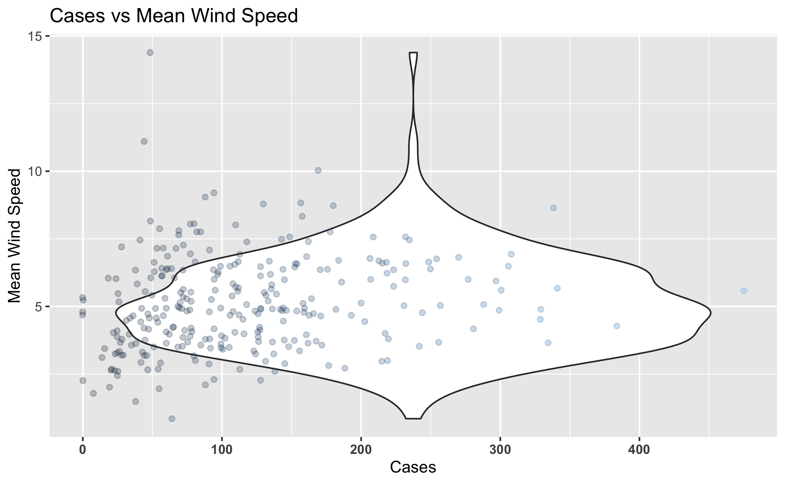

Figure 9: Number of Dengue Cases Weekly against the Mean Wind Speed.

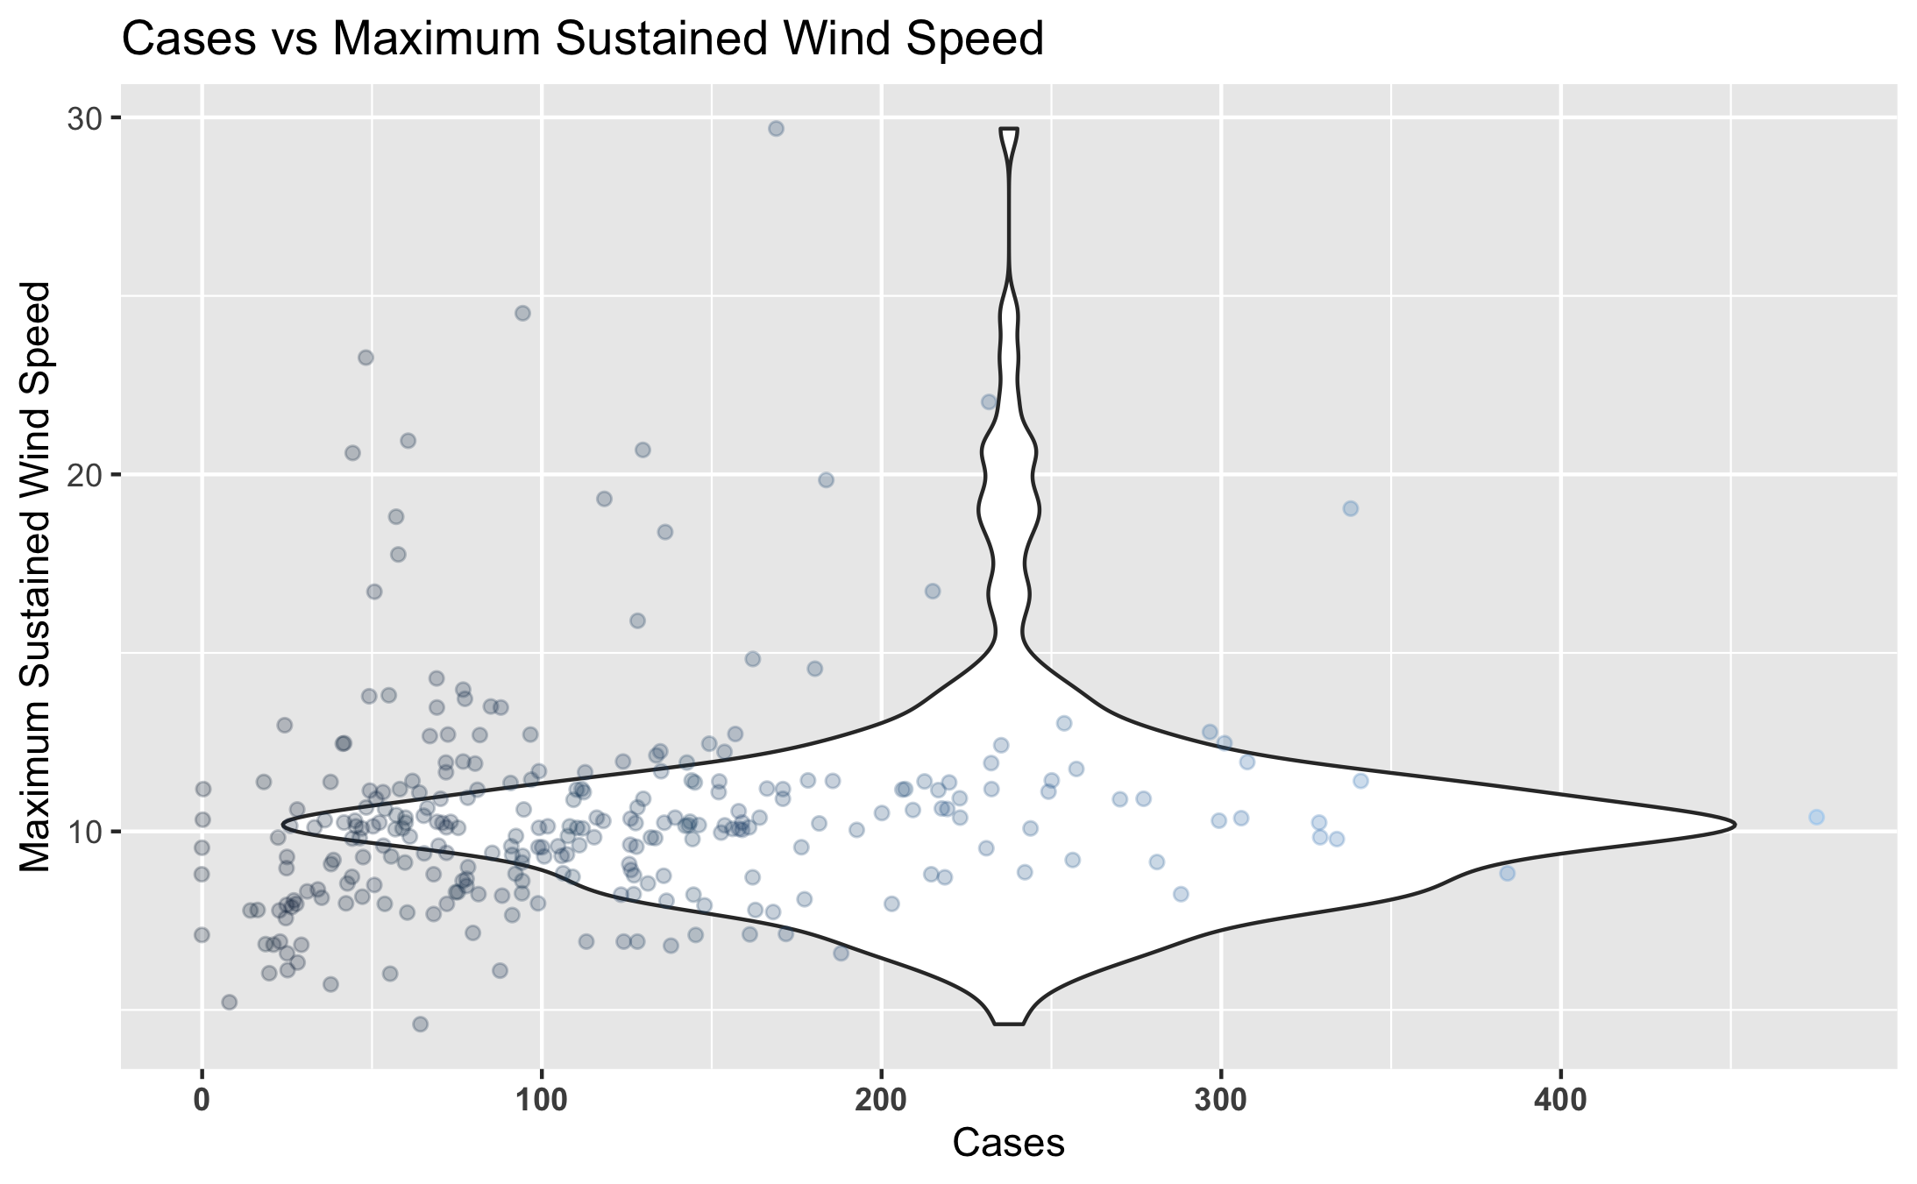

Figure 10: Number of Dengue Cases Weekly against Maximum Wind Speed.

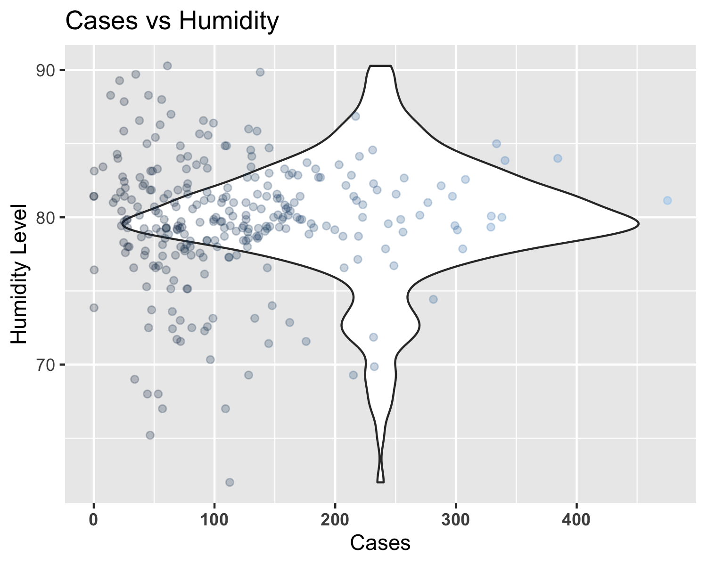

Figure 11: Number of Dengue Cases Weekly against Relative Humidity.

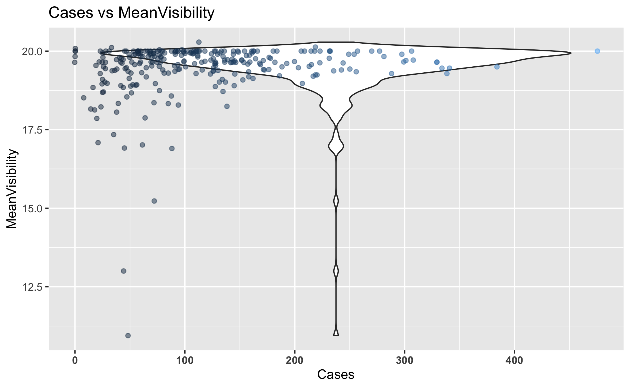

Figure 12: Number of Dengue Cases Weekly against Mean Visibility.

## Bivariate Analysis

*Create plots or tables and compute simple statistics (e.g. t-tests, simple regression model with 1 predictor, etc.) to look for associations between your outcome(s) and each individual predictor variable*

*A Bivariate Analysis is the simultaneous analysis of two variables (attributes). It explores the concept of relationship between two variables, whether there exists an association and the strength of this association, or whether there are differences between two variables and the significance of these differences.*

*First we will look at a simple Correlation among our variables.*

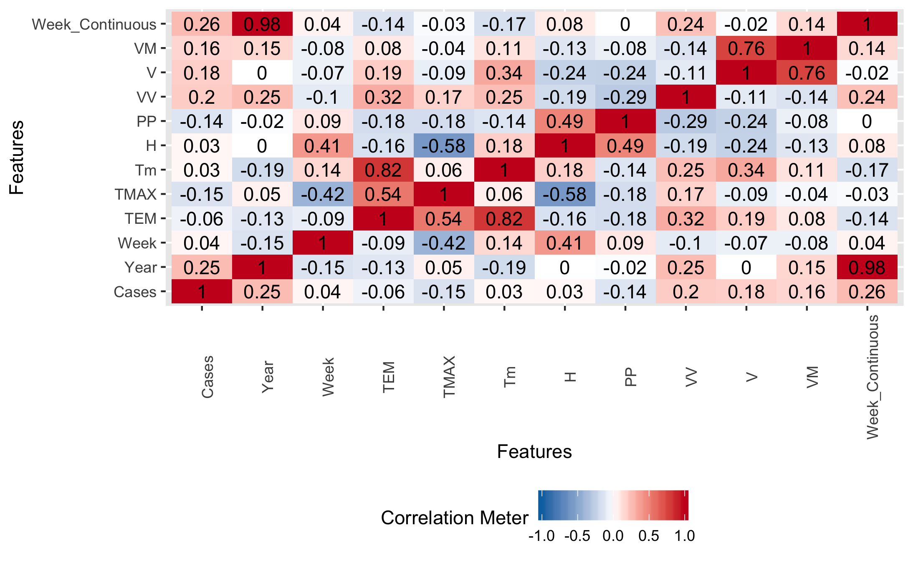

Figure 13: Correlation among Variables.

### Climate Condition Comparisons

*For the first part of this analysis, we will examine a few variables against each other: Average temperature of the week (TEM), Relative humidity (H), Precipitation Level (PP), and Mean wind speed (V). We are looking for any general trends among these climate conditions.*

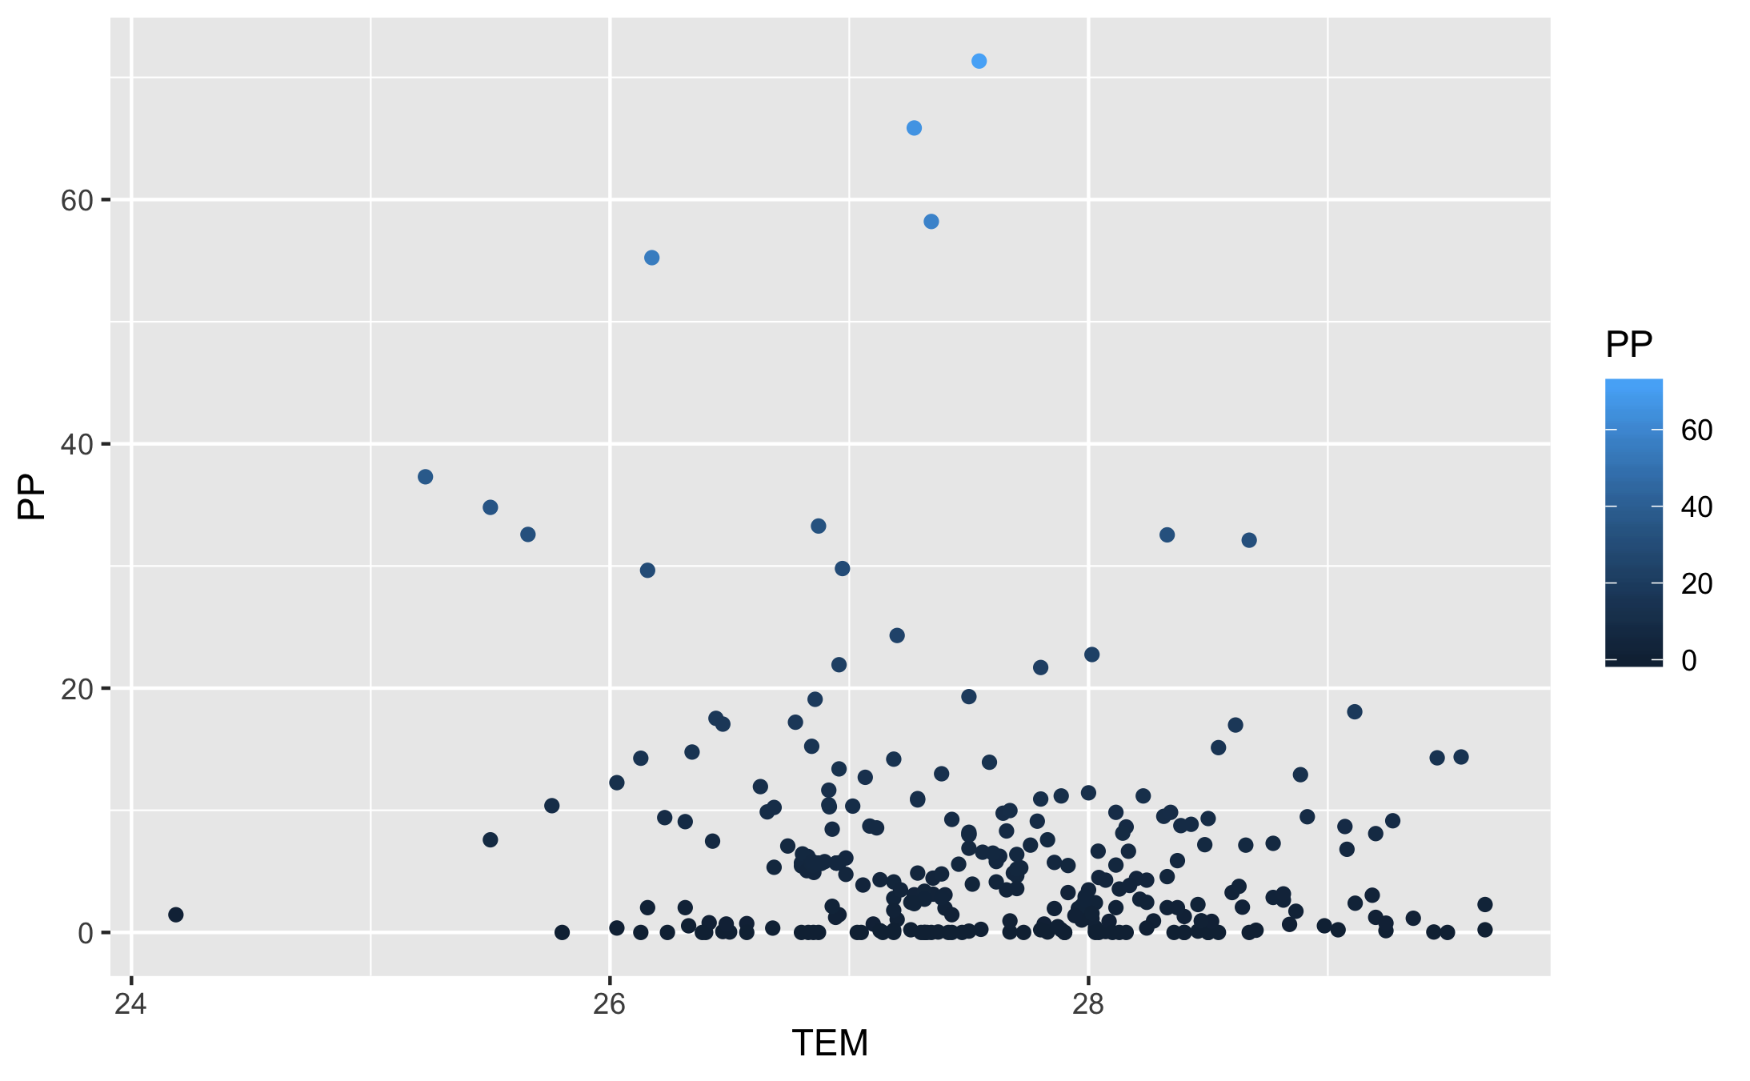

Figure 14: Comparison of Average Temperature versus Average Precipitation.

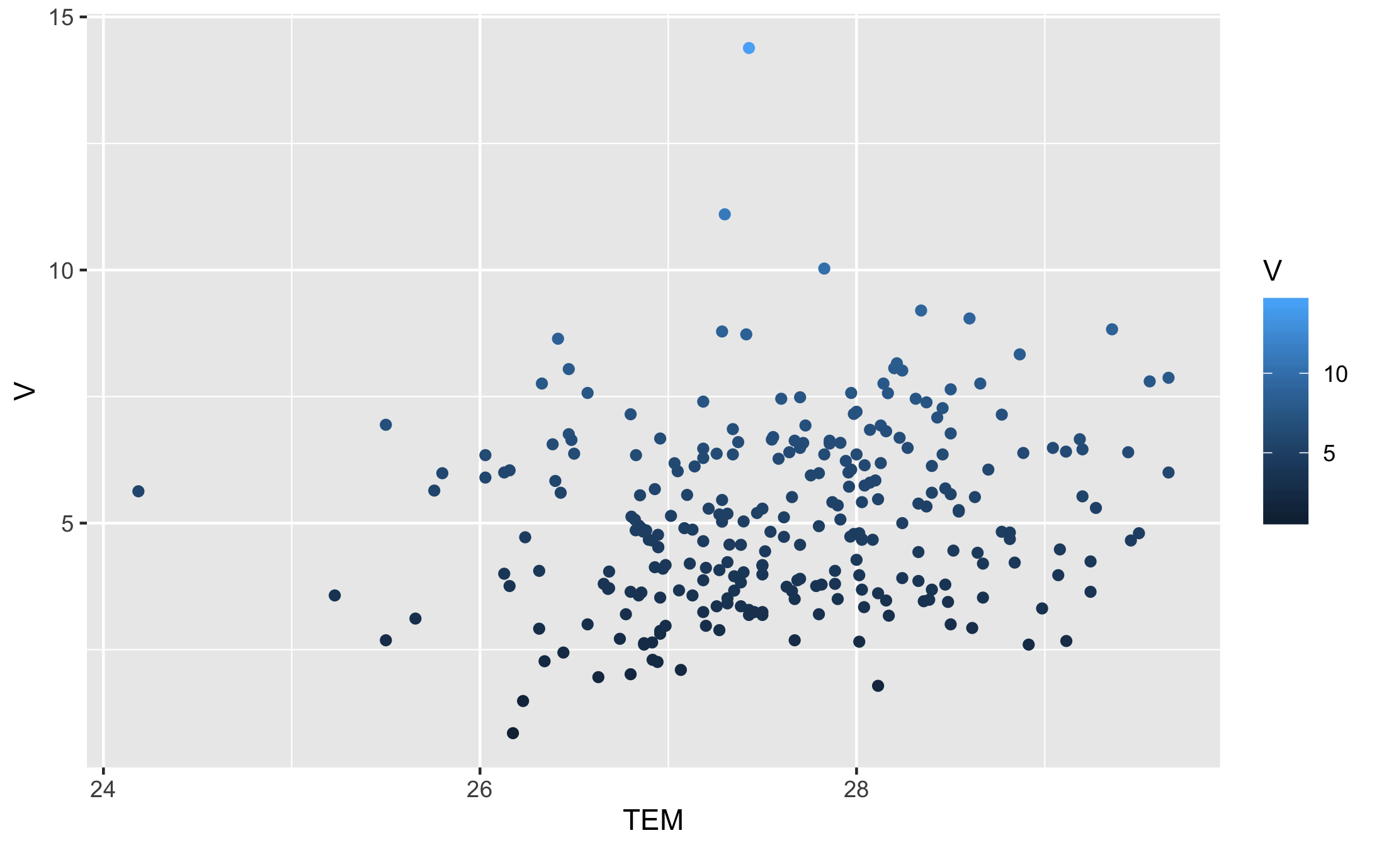

Figure 15: Comparison of Average Temperature versus Mean Windspeed.

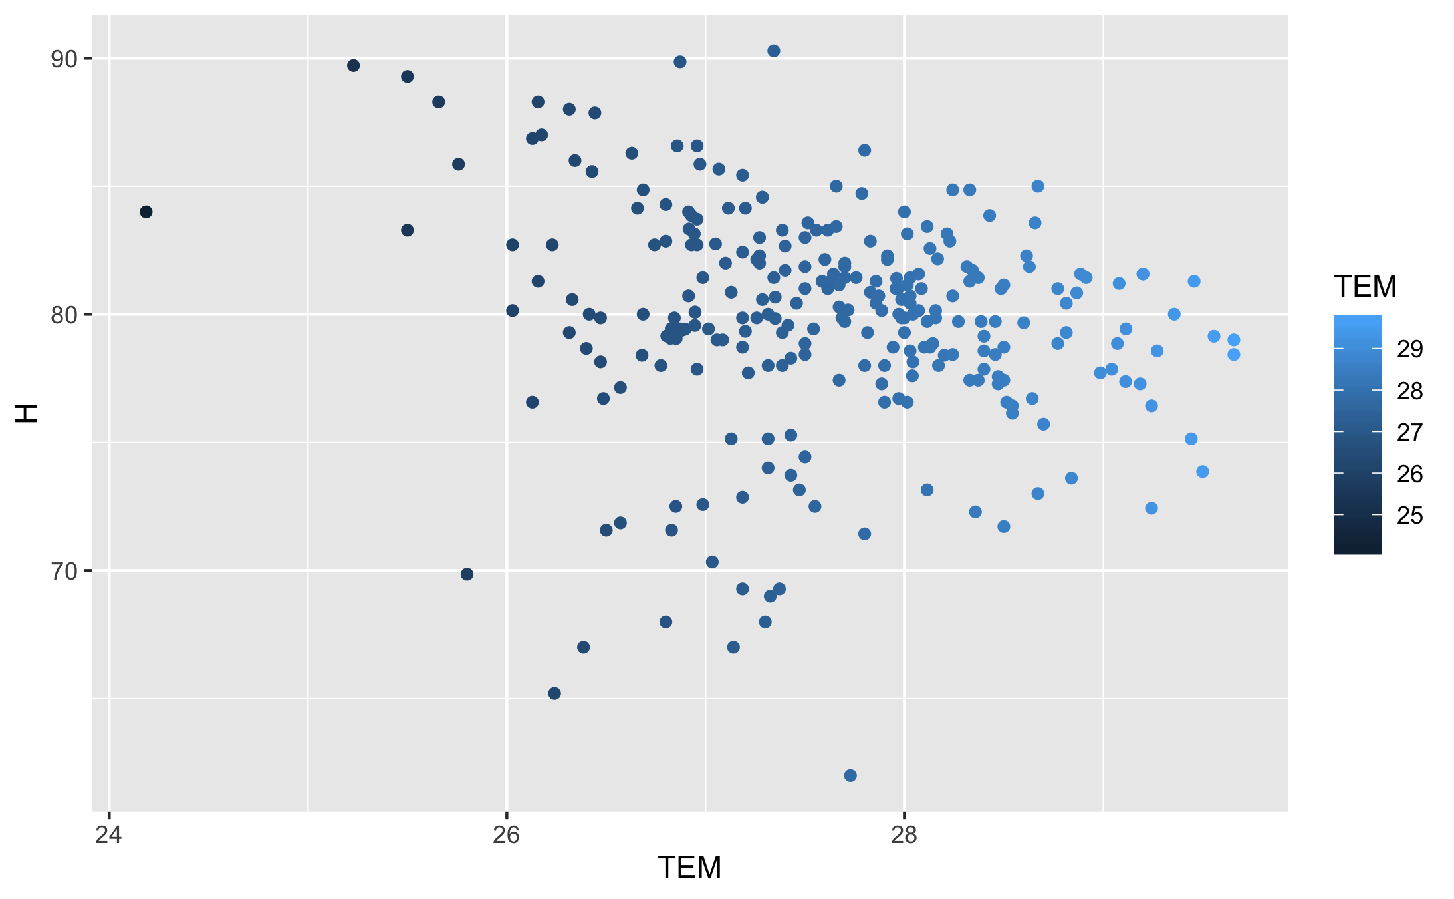

Figure 16: Comparison of Average Temperature versus Relative Humidity.

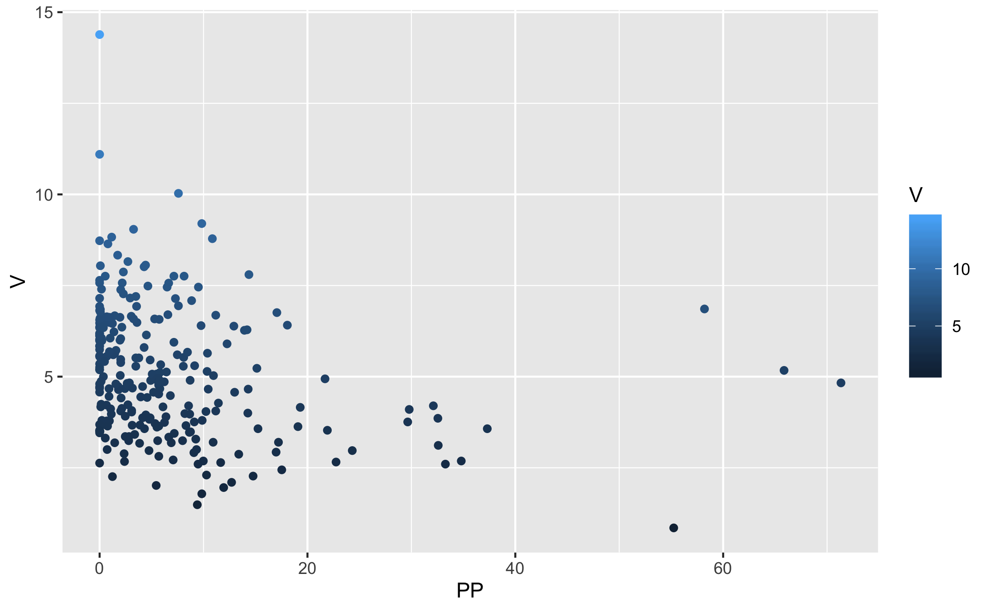

Figure 17: Comparison of Average Precipitation versus the Mean Windspeed.

Figure 18: Comparison of Relative Humidity versus Average Precipitation.

Figure 18: Comparison of Relative Humidity versus Average Precipitation.

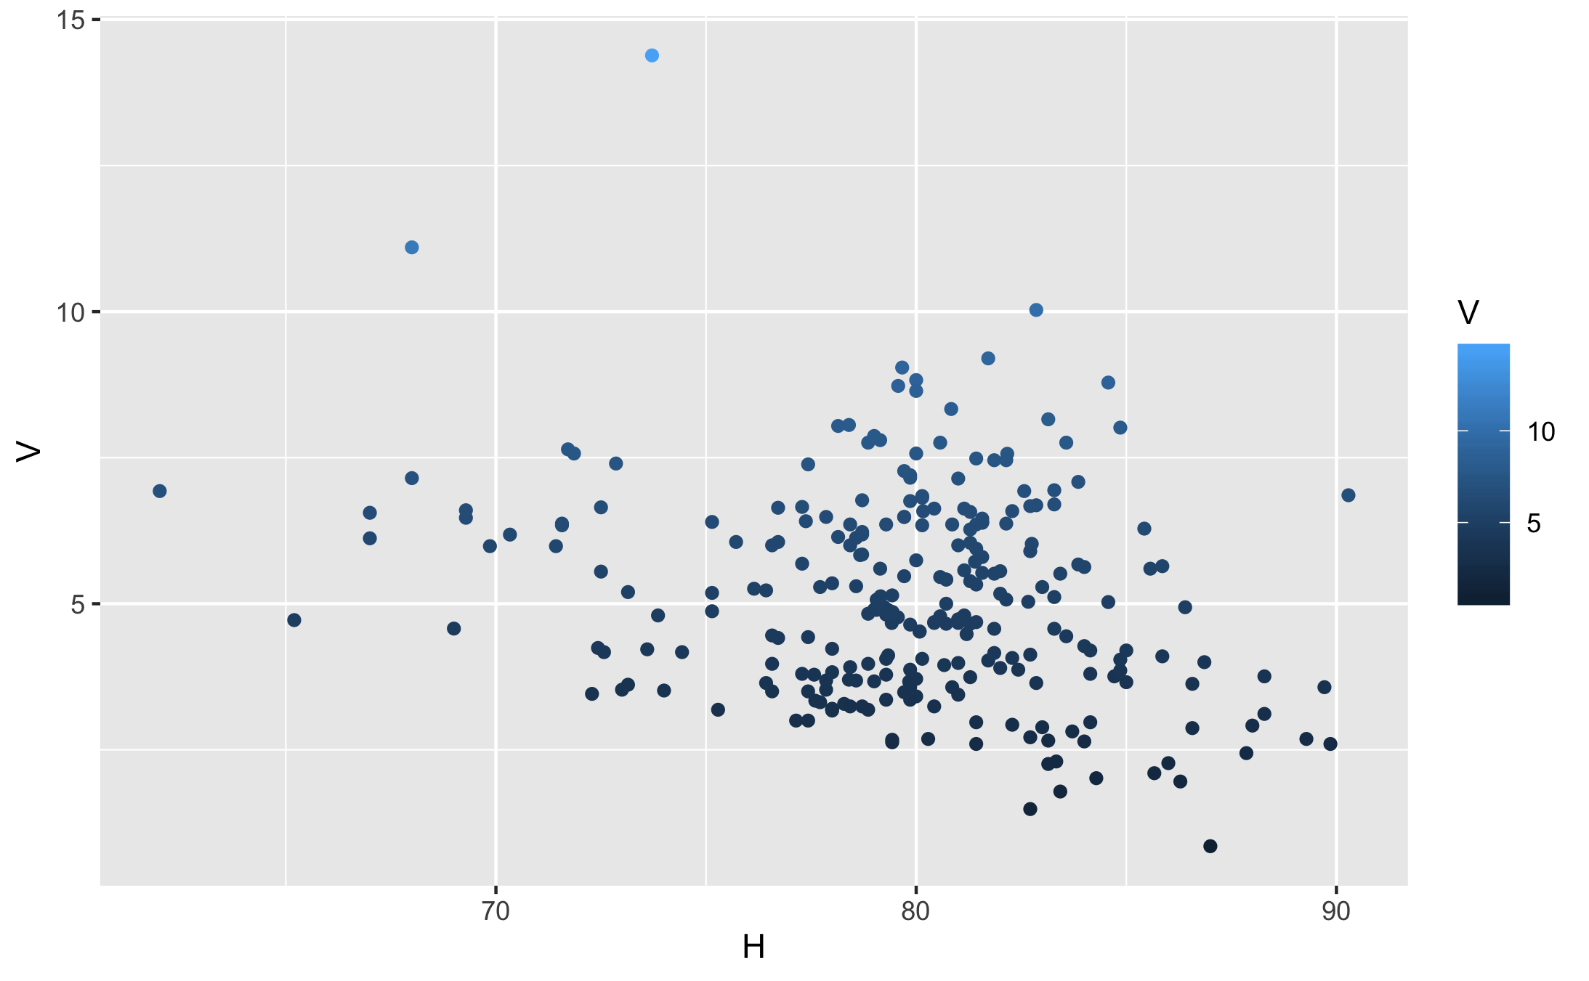

Figure 19: Comparison of Relative Humidity versus Mean Windspeed.

*From what we can see, we can make some general assumptions based on the graphs as well as what we know to be common knowledge about weather effects. Looking at the graphs, Lower Temperatures are usually correlated with more more Percipitation, and Higher Humidity is correlated with higher Percipitation.*

### Seasonal Changes

*Another aspect I want to look at would be examining seasonal changes and seeing as how they compare to the number of Cases of Dengue. Using this we can hopefully find some additional correlations and break down the information to get a more in depth visualization of how the number of cases of Dengue changes seasonally. Sri Lanka’s climate is tropical and consists of distinct wet and dry seasons. Generally speaking, the coastal areas of Sri Lanka enjoy temperatures averaging 28°C (82°F) while the upland areas are cooler and more temperate, with a yearly average around 16-20°C (60-68°F). Our data was collected in the Colombo district, which lies on the western side of Sri Lanka. It is Sri Lanka’s largest city, and often hot, wet, and humid year-round.*

*Here we examine the Temperature changes across the time.*

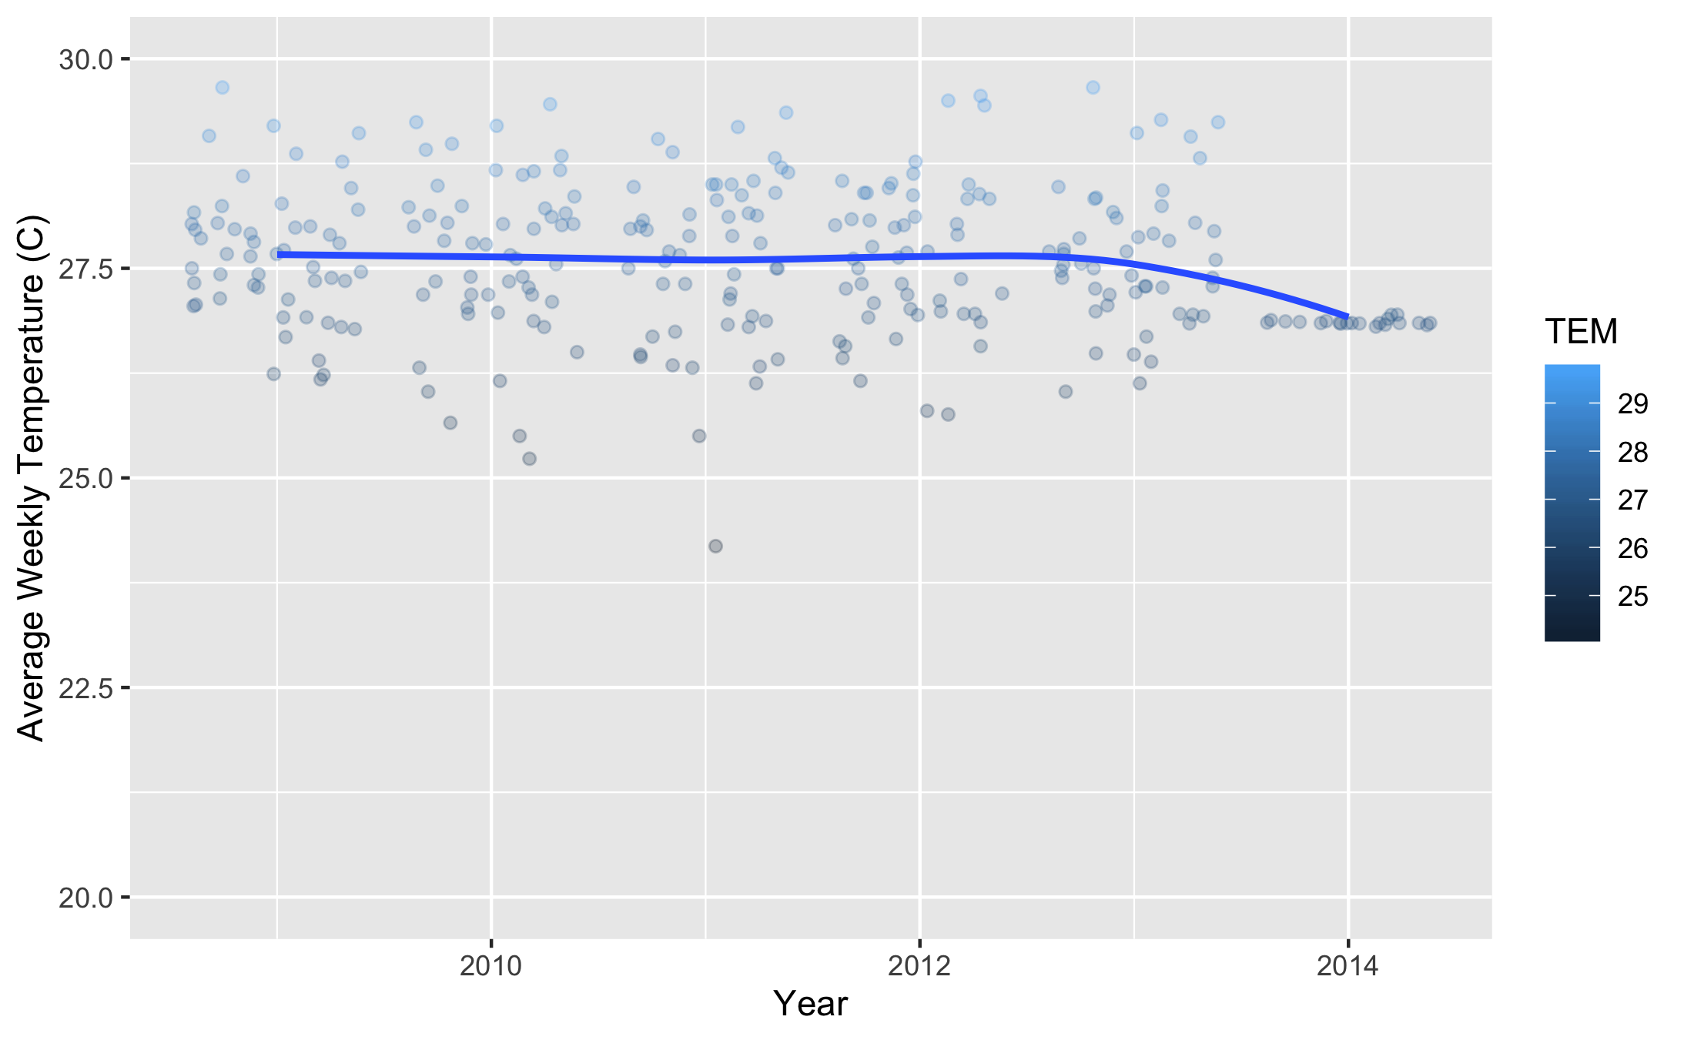

Figure 20: Comparison of Average Temperature Across Years.

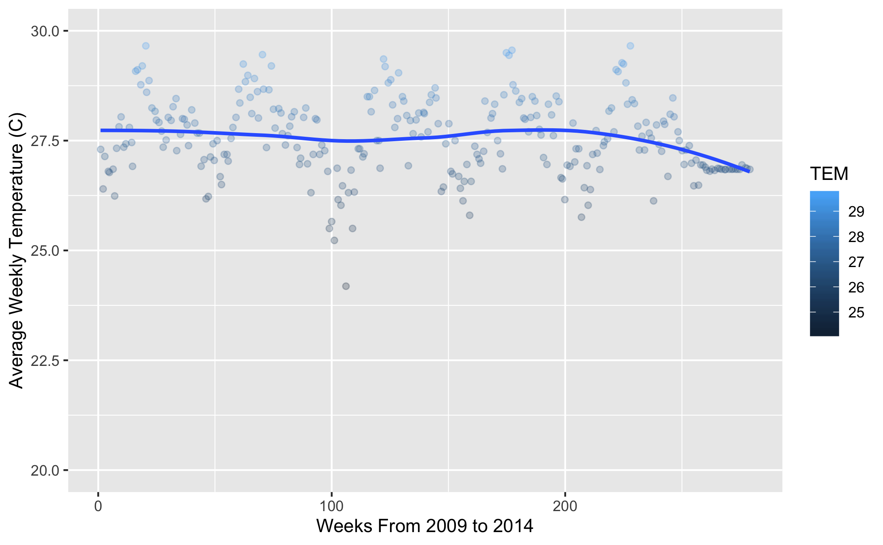

Figure 21: Comparison of Average Temperature Across Each Week Continuously.

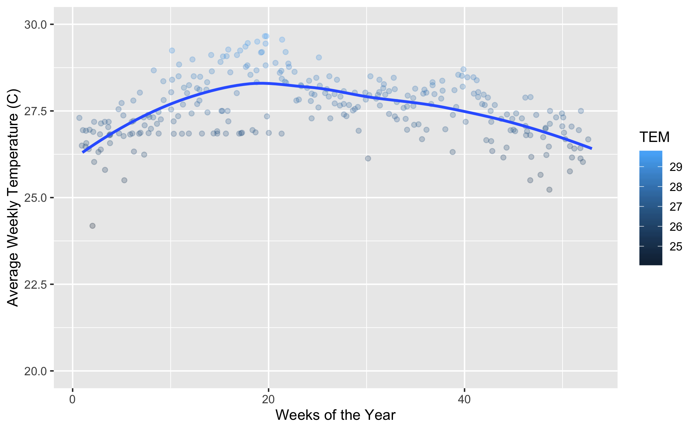

Figure 22: Comparison of Average Temperature Across Each Week of the Year.

*Our temperatures seem to fluctuate normally throughout the months and years present. Now let’s check out some other variables in a comparison before finally comparing it to the Cases of Dengue. What we are looking for is something interesting to account for months with higher cases of Dengue. Here we will check out how the Precipitation changes over time.*

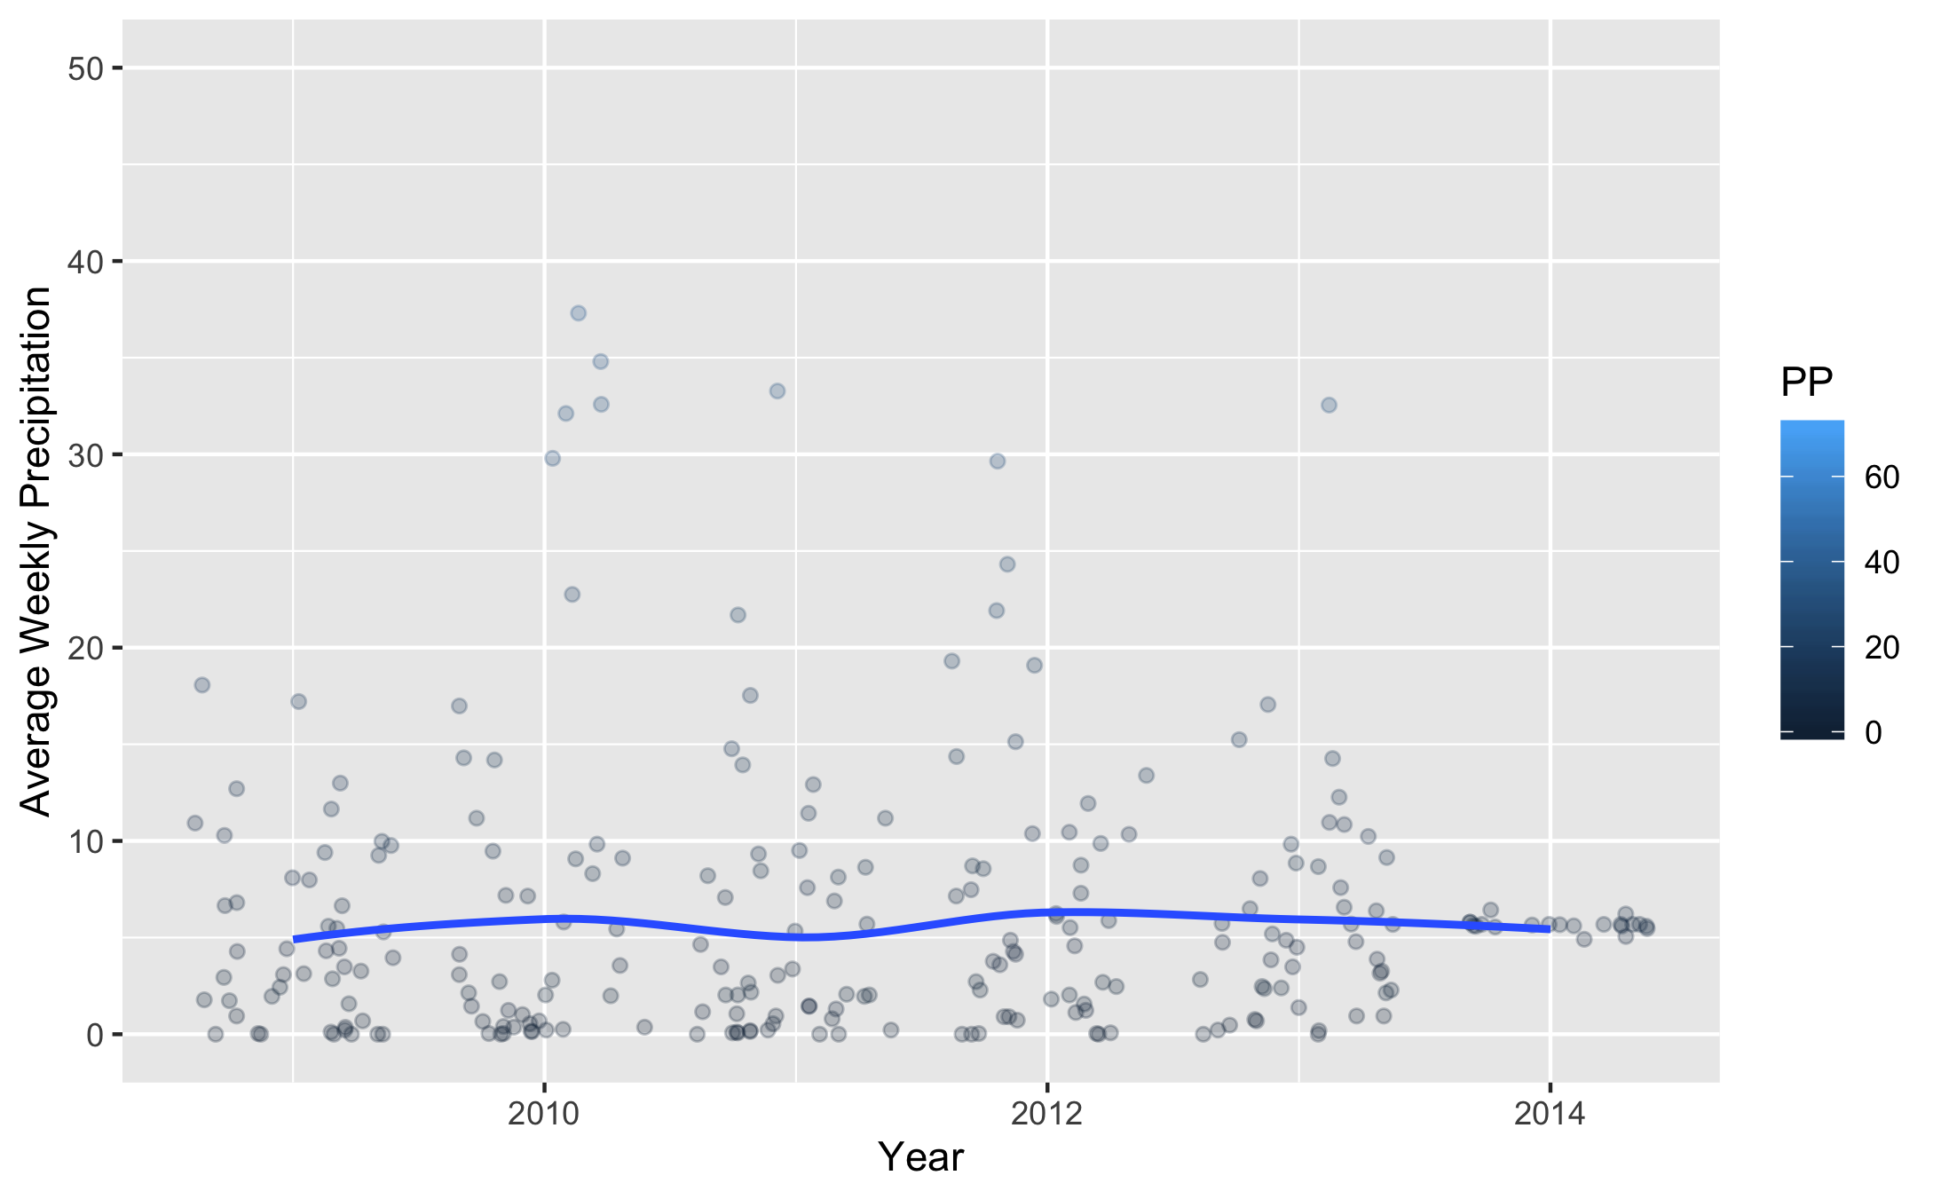

Figure 23: Comparison of Average Precipitation Across Years.

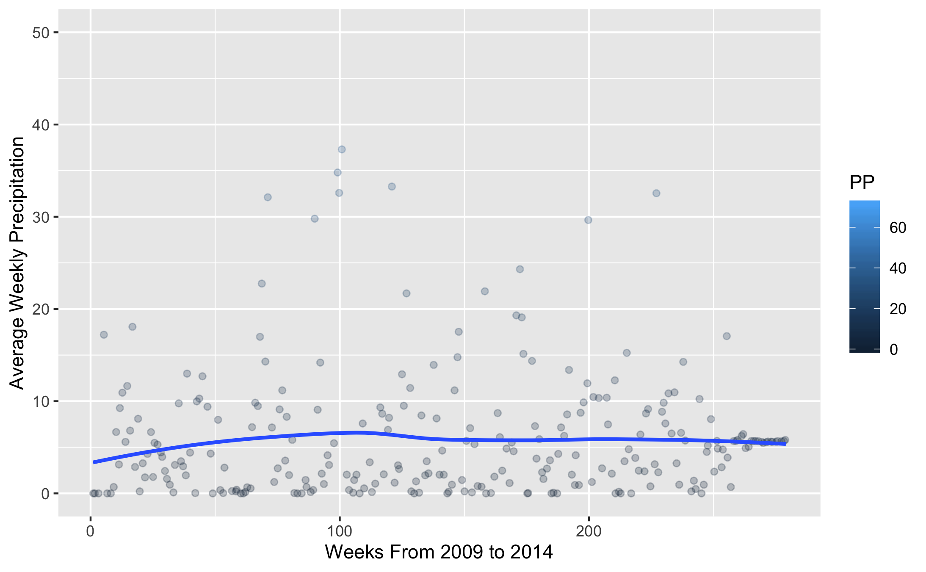

Figure 24: Comparison of Average Precipitation Across Each Week Continuously.

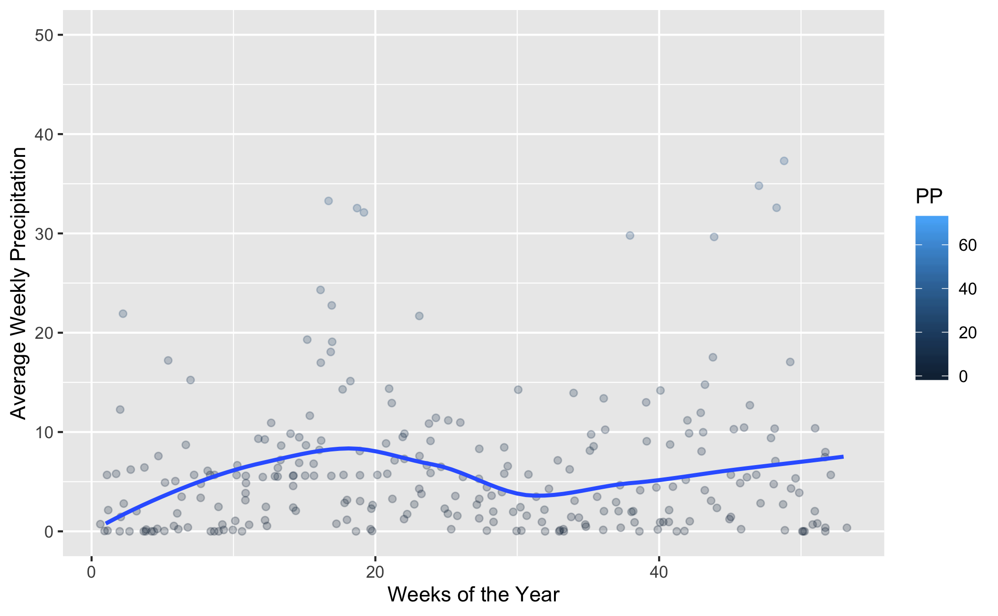

Figure 25: Comparison of Average Precipitation Across Each Week of the Year.

*Now we will examine the changes in Humidity.*

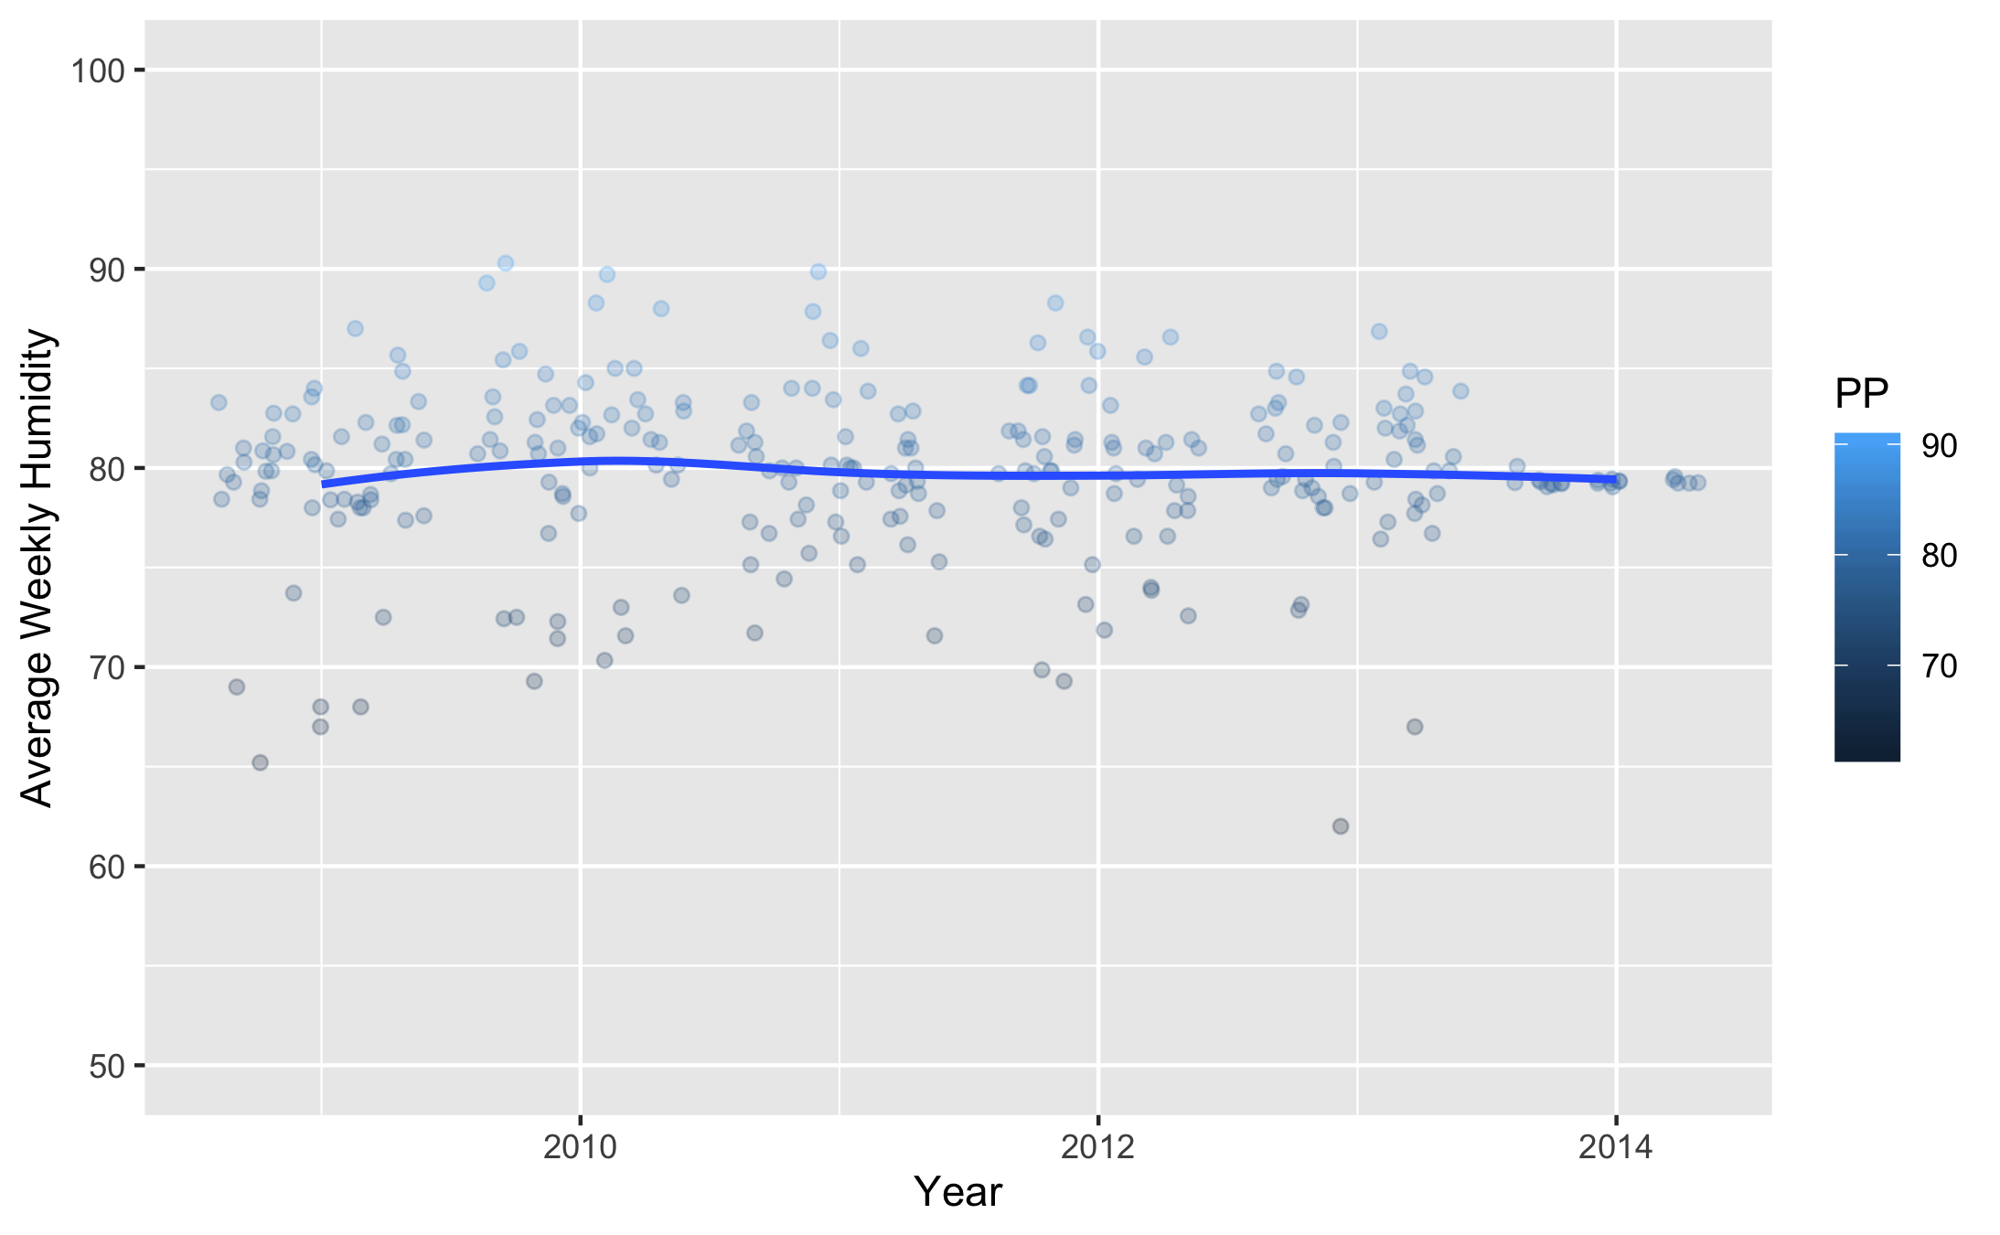

Figure 26: Comparison of Relative Humidity Across Years.

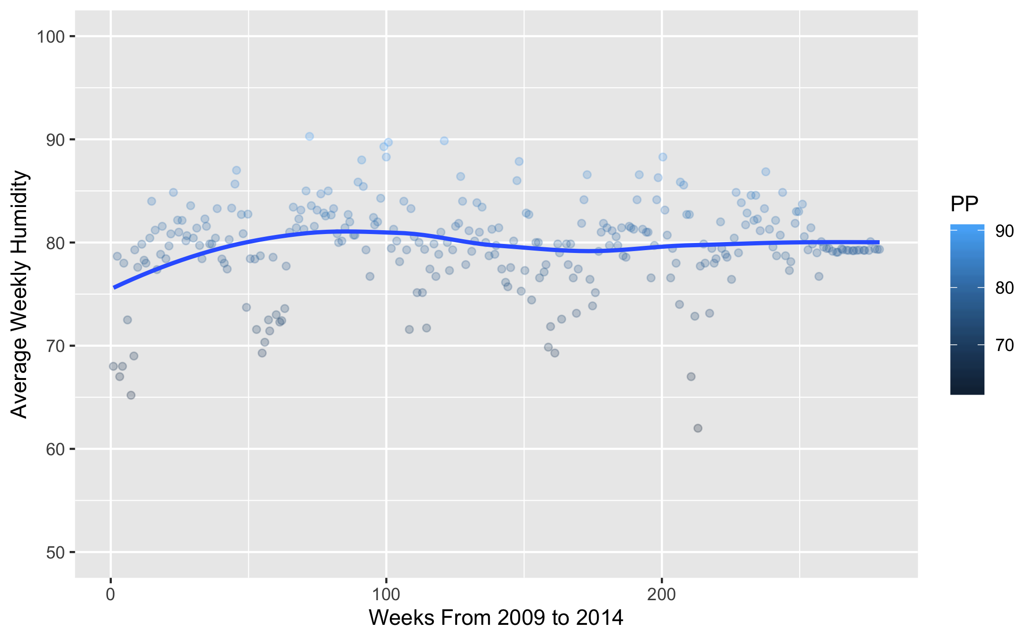

Figure 27: Comparison of Relative Humidity Across Each Week Continuously.

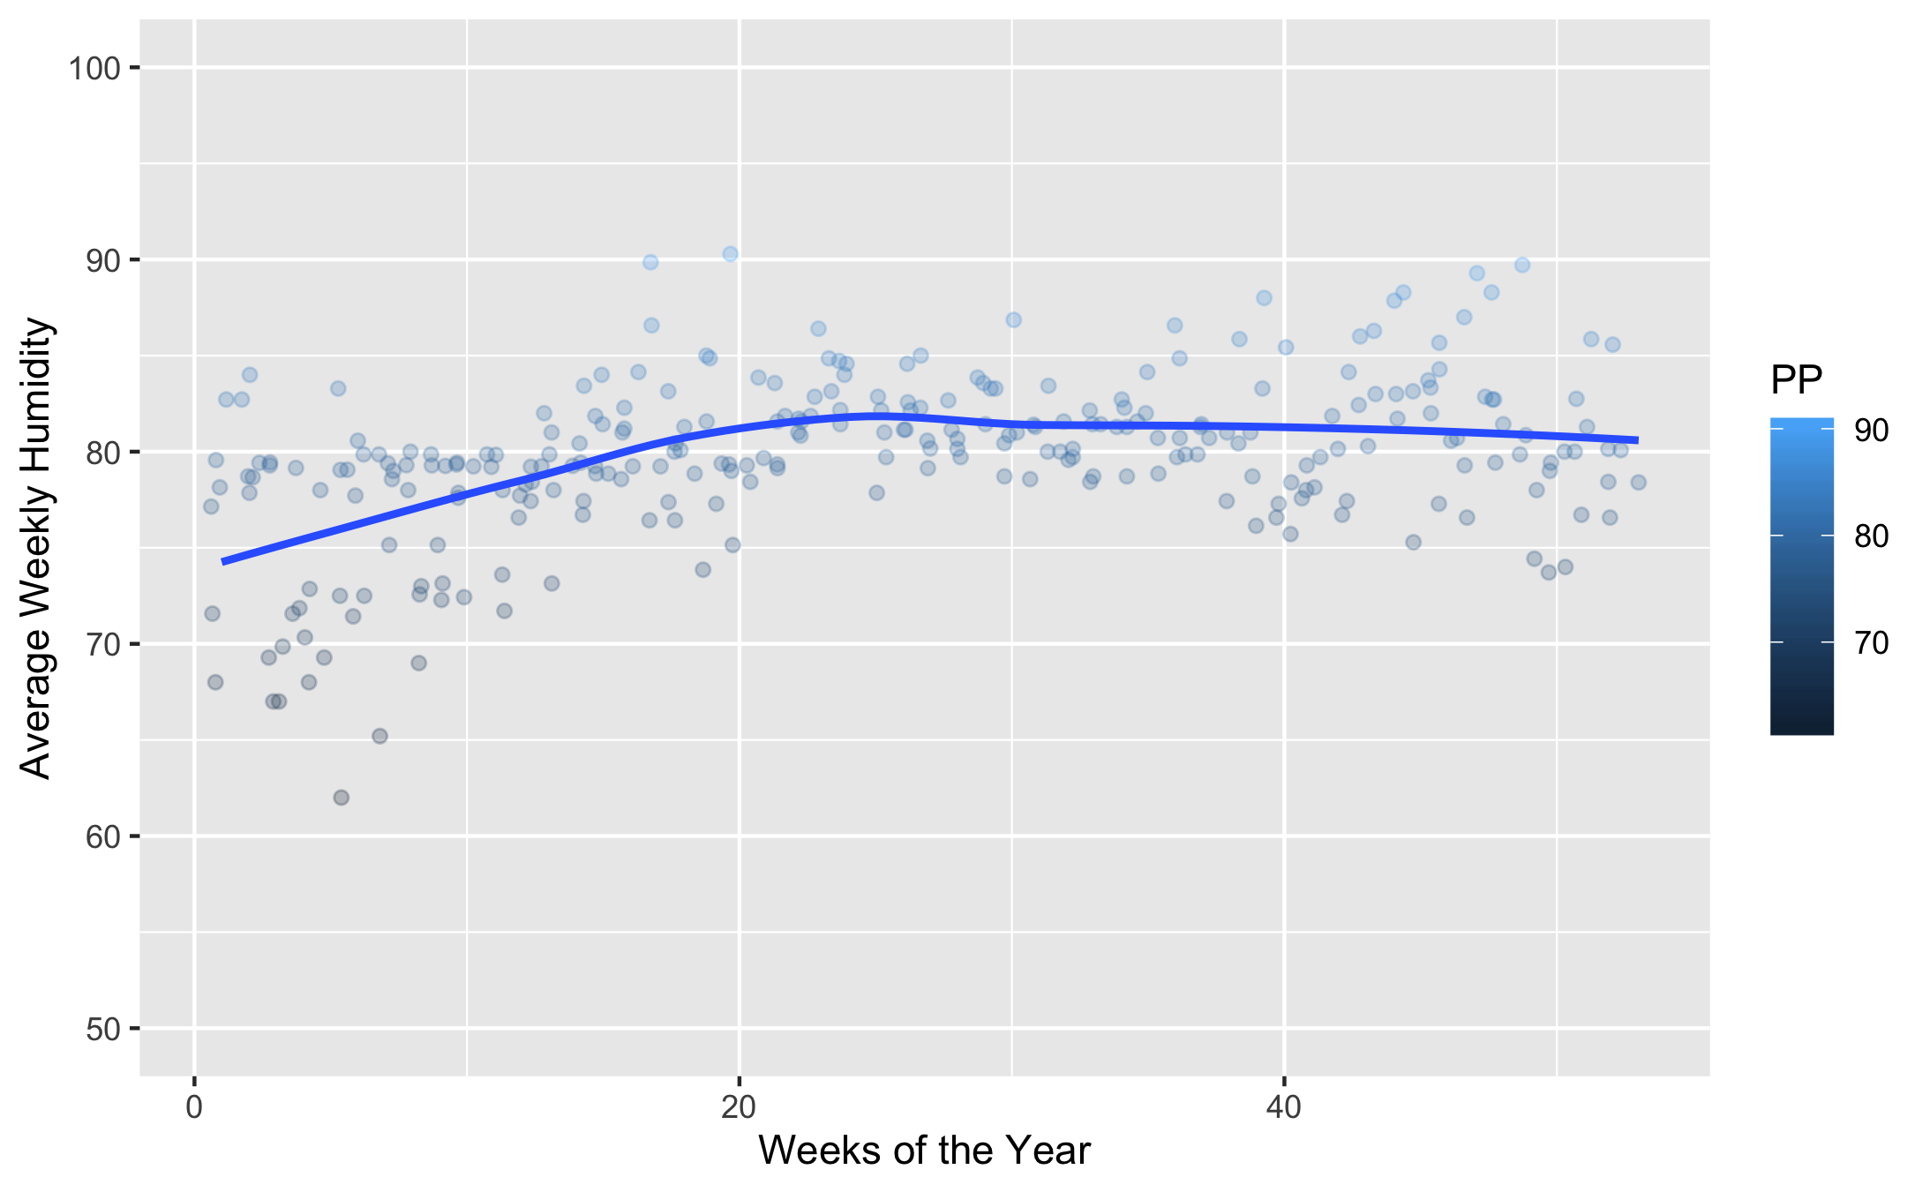

Figure 28: Comparison of Relative Humidity Across Each Week of the Year.

*Here are the changes in the Mean Windspeed.*

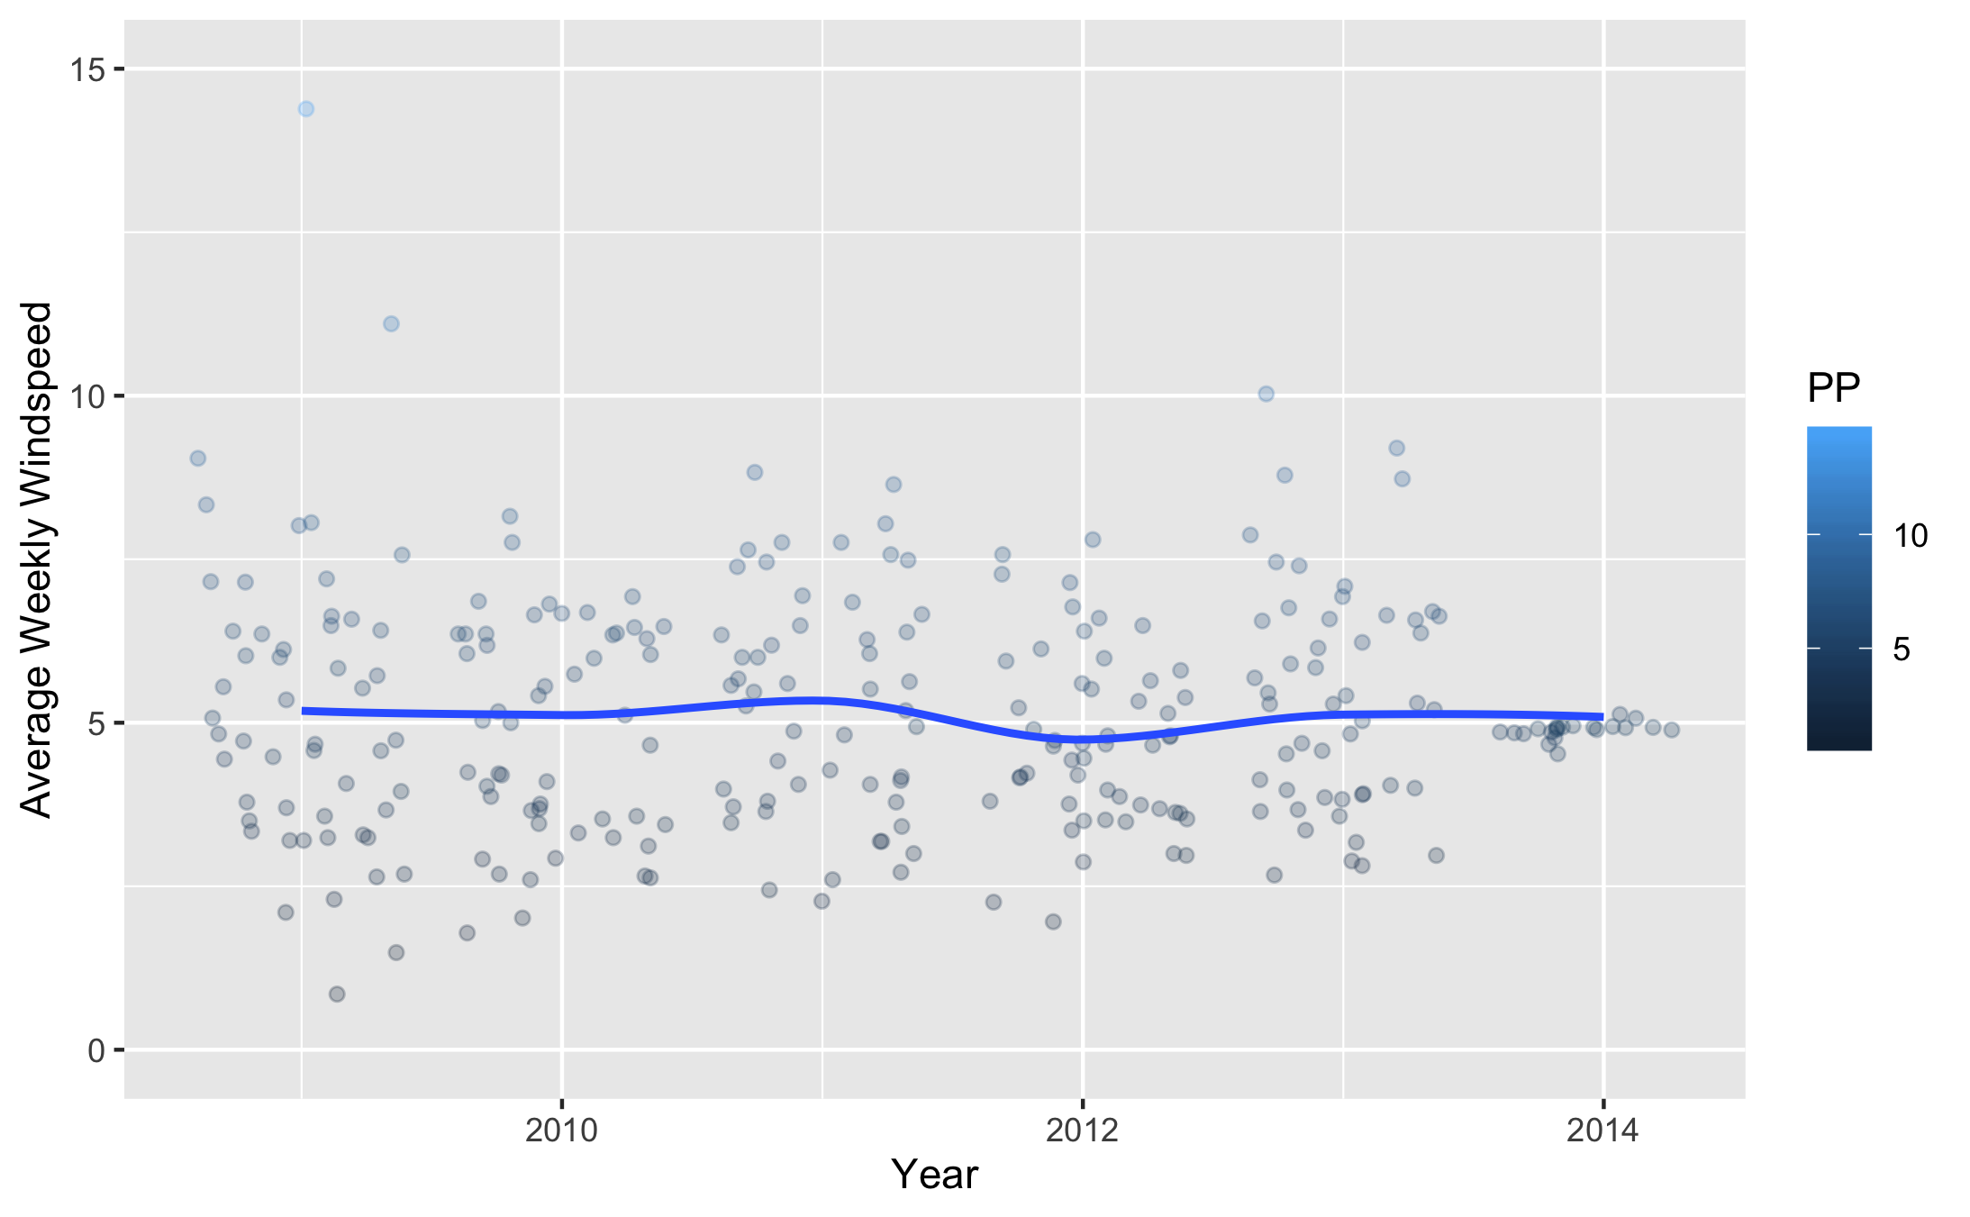

Figure 29: Comparison of Mean Windspeed Across Years.

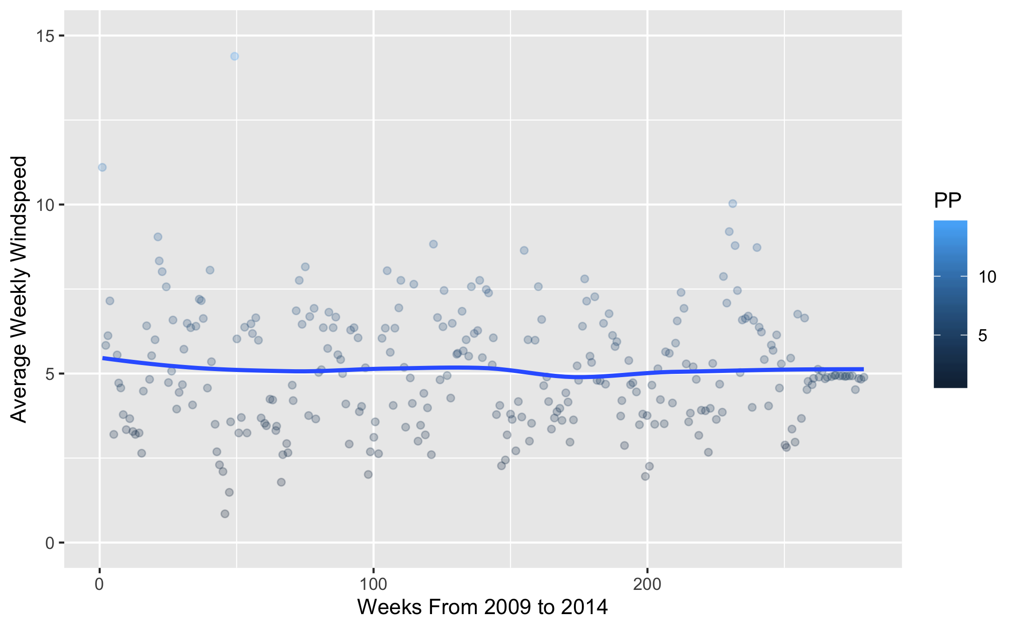

Figure 30: Comparison of Mean Windspeed Across Each Week Continuously.

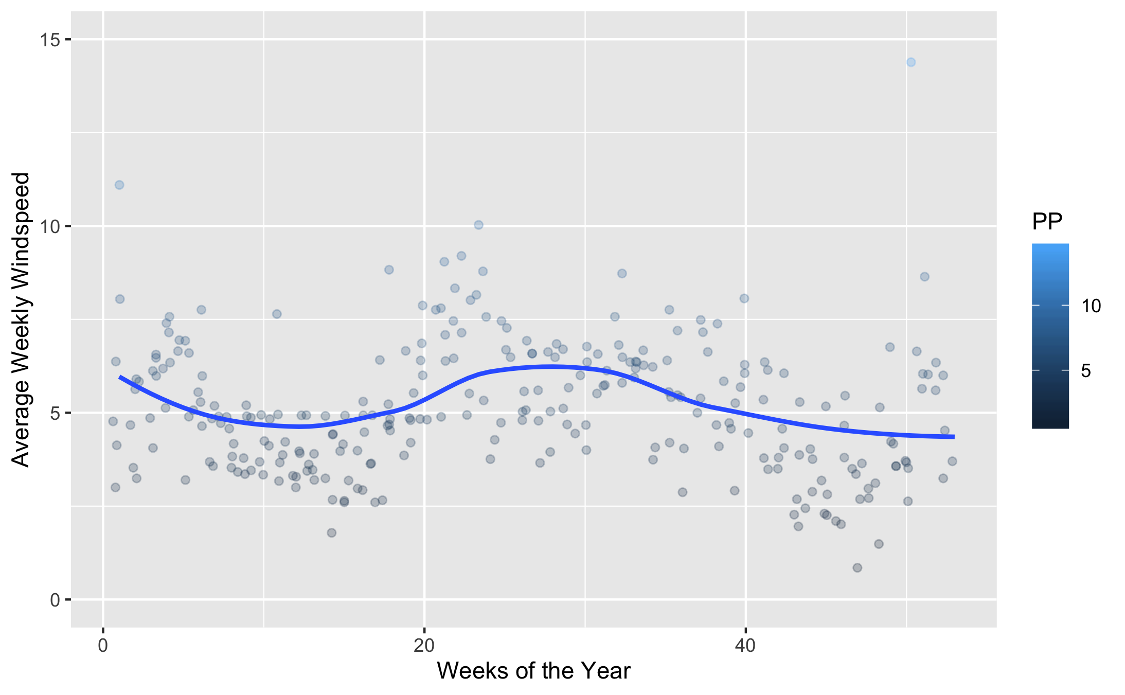

Figure 31: Comparison of Average Temperature Across Each Week of the Year.

## Full Analysis

*Use one or several suitable statistical/machine learning methods to analyze your data and to produce meaningful figures, tables, etc. This might again be code that is best placed in one or several separate R scripts that need to be well documented. You can then load the results produced by this code*

# Discussion

## Summary and Interpretation

*Summarize what you did, what you found and what it means.*

## Strengths and Limitations

*Discuss what you perceive as strengths and limitations of your analysis.*

## Conclusions

*What are the main take-home messages?*

*Include citations in your Rmd file using bibtex, the list of references will automatically be placed at the end*

# References

Leek, J. T., & Peng, R. D. (2015). Statistics. What is the question? *Science (New York, N.Y.)*, *347*(6228), 1314–1315. <https://doi.org/10.1126/science.aaa6146>